Tarlac State University

**COLLEGE OF COMPUTER STUDIES**

# Case Study

in

Integrative

# Programming Technology 2

Submitted By:

**Atchazo, Jake Cris N.**

**Batomalaque, Vance Levin S.**

**Mina, Mark Denver D.**

**Rodrigueza, Loraine P.**

**Yabes, Shina B.**

Submitted To:

**Millet, Axel D.**

Date: September 2025

**Table of Contents**

1. **Definition..........................................................................................................................................** 3
2. **Case Analysis (Git and GitHub Workflow) ..................................................................................** 4
   1. **Atchazo Documentation .............................................................................................................** 4
      1. **Remote Repository (GitHub) Creating a Milestone ................................................................** 4
      2. **Local Repository (Git) ................................................................................................................** 6
3. **Case Analysis (Git and GitHub Workflow) ................................................................................** 16
   1. **Batomalaque Documentation...................................................................................................** 16
      1. **Remote Repository (GitHub) Creating a Milestone ..............................................................** 16
      2. **Local Repository (Git) ..............................................................................................................** 17
4. **Case Analysis (Git and GitHub Workflow) ................................................................................** 46
   1. **Mina Documentation ................................................................................................................** 46
      1. **Remote Repository (GitHub) Milestone .................................................................................** 46
      2. **Local Repository (Git) ..............................................................................................................** 48
5. **Case Analysis (Git and GitHub Workflow) ................................................................................** 56
   1. **Rodrigueza Documentation .....................................................................................................** 56
      1. **Remote Repository (GitHub) Creating a Milestone ..............................................................** 56
      2. **Local Repository (Git) ..............................................................................................................** 58
6. **Case Analysis (Git and GitHub Workflow) ................................................................................** 56
   1. **Yabes Documentation ...............................................................................................................** 56
      1. **Remote Repository (GitHub) Creating a Milestone ..............................................................** 56
      2. **Local Repository (Git) ..............................................................................................................** 58
7. **Individual HTML ...............................................................................................................................** 68
8. **References ......................................................................................................................................** 70

## A. Definition

Create a static website upload the documentation and files in your GitHub repository and add a minimum of 3 more webpages to add in your repository during the development use Git and GitHub and create a documentation of all steps made during the development.

On the website, each member will create their own portfolio (webpage) in a resume type with full details, each team can pick a theme for their website for unity.

**Requirements:**

* Each member in your group will need to upload **a webpage**
* Create a **Pull Request** for each member in Github with comments.
* Create an **Issue** for each member in Github and comment.
* Create a **Milestone** for the group in Github.
* Create a branch for each member and merge it with your main in Github.

* **Git clone** - Creates a copy of an existing Git repository. Cloning is the most common way for developers to obtain a working copy of a central repository.[1]

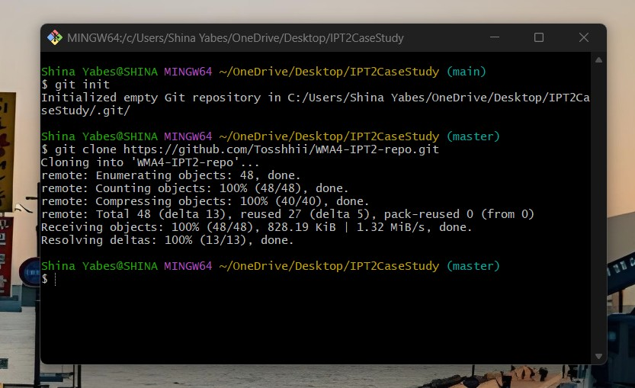

* **Git Pull** - Pulling is the automated version of git fetch. It downloads a branch from a remote repository, then immediately merges it into the current branch. This is the Git equivalent of svn update.[3]

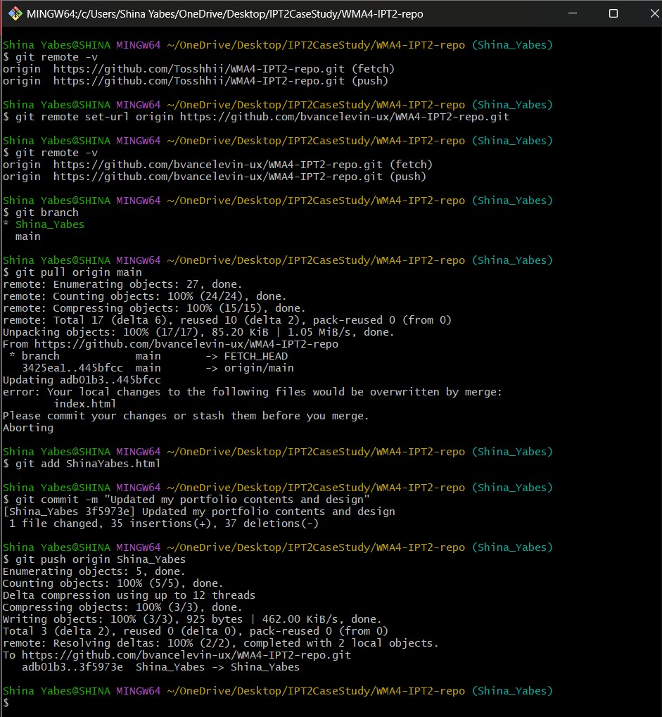

* **Git Push** - Pushing is the opposite of fetching (with a few caveats). It lets you move a local branch to another repository, which serves as a convenient way to publish contributions. This is like svn commit, but it sends a series of commits instead of a single changeset.[3]

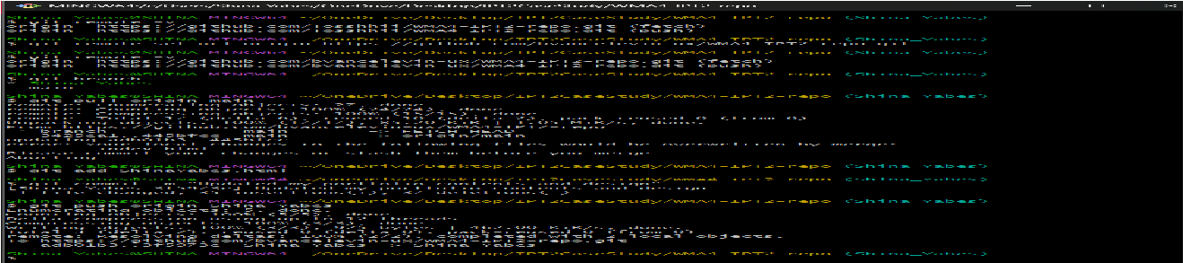

* **Git Merge** - A powerful way to integrate changes from divergent branches. After forking the project history with git branch, git merge lets you put it back together again.[3]

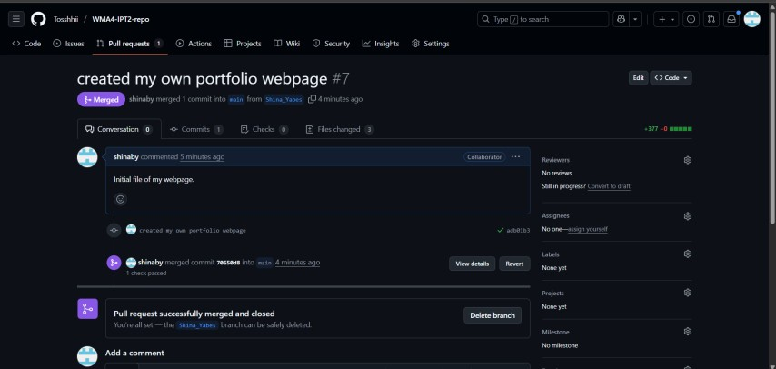

* **Issue** - is a lightweight issue-tracking system that is available in all GitHub repositories. When you create a GitHub repo, you get GitHub Issues out of the box, and more often than not, you keep using it as your project evolves.[2]

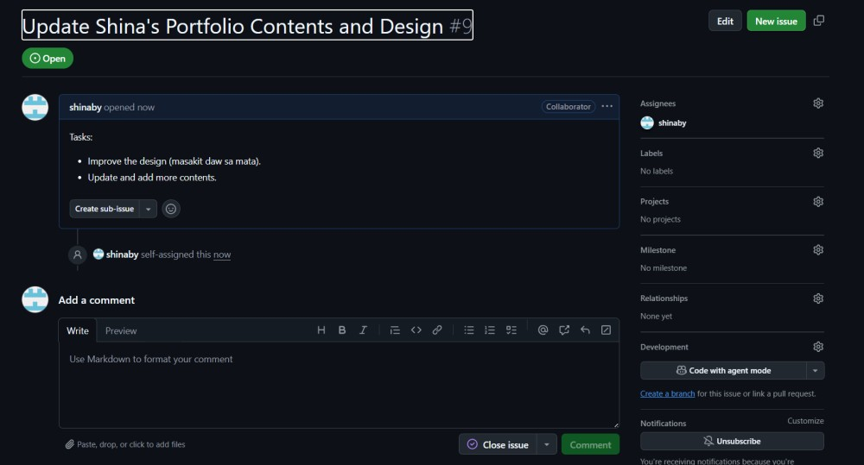

* **Pull Request** - Pull requests are a feature that makes it easier for developers to collaborate using Bitbucket. They provide a user-friendly web interface for discussing proposed changes before integrating them into the official project.[3]

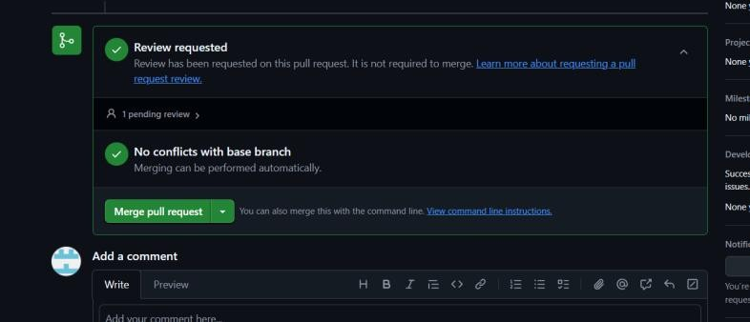

* **Milestone** - are a way of organizing issues into smaller "sub-projects" - smaller than the whole "project". When all issues are done/closed, the milestone can be regarded as complete.[4]

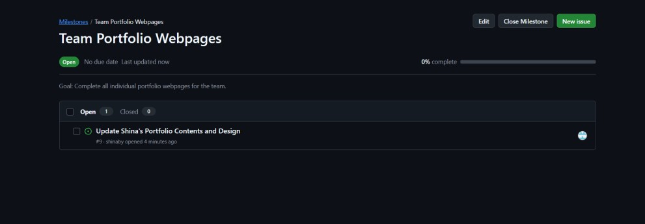

* **Branch** - A branch represents an independent line of development. Branches serve as an abstraction for the edit/stage/commit process discussed in Git Basics, the first module of this series. You can think of them as a way to request a brand new working directory, staging area, and project history. New commits are recorded in the history for the current branch, which results in a fork in the history of the project.[3]

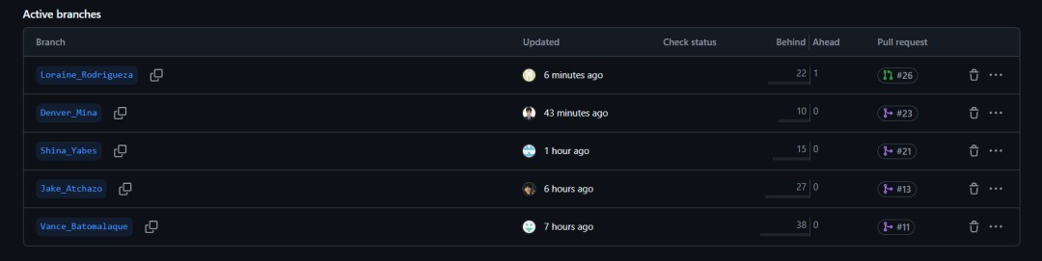

**Contributions:**

|  |  |
| --- | --- |
| **Contributions** | **Members** |
| Creating a Repository | Atchazo, Jake Cris N. |
| Creating Individual Branches | All members |
| Creating Individual Portfolios | All members |
| Creating and Enhancing Homepage | Atchazo, Jake Cris N.  Batomalaque, Vance Levin S. |
| Creating Milestone | Yabes, Shina B. |
| Creating Issues | Atchazo, Jake Cris N. |

|  |  |
| --- | --- |
|  | Mina, Mark Denver D. Yabes, Shina B. |
| Linking Issues to Milestones | Atchazo, Jake Cris N.  Mina, Mark Denver D.  Yabes, Shina B. |
| Creating Pull Requests | All members |
| Approving Pull Requests | All members |
| Merging Pull Requests into Main | All members |
| Definition of Commands | Yabes, Shina B. |
| Individual Project Documentation | All members |
| Compiling References | Yabes, Shina B. |
| Maintaining Documentation Updates | All members |
| Main Documentation Writing | Yabes, Shina B. |
| Managing Group Collaboration | All members |

## B. Case Analysis (Git and GitHub Workflow)

B. 1 Atchazo’s Documentation

* created folder for local repo

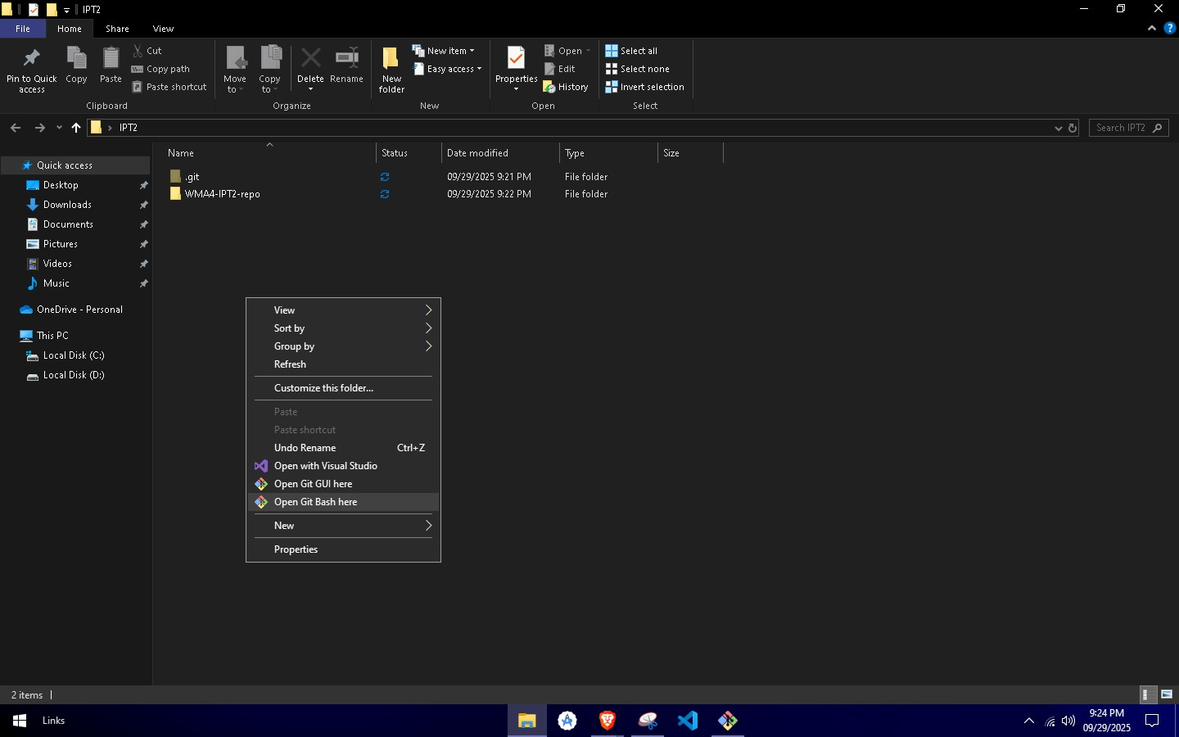

* Right click to open options and click open git bash

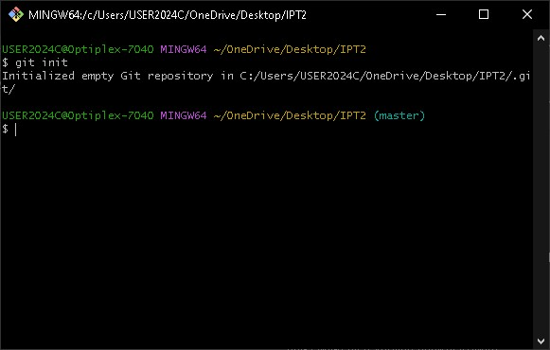

* I used git init to initialize the folder as a local repo

Documentation on how to setup the local repo

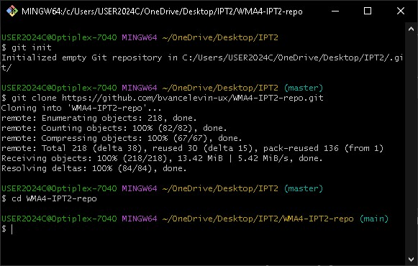

* After initializing the local repo, it’s time to initialize the remote repository as local repository using git clone to clone to remote repository to the local folder repo

Documentation on how to setup the remote/connect to repo

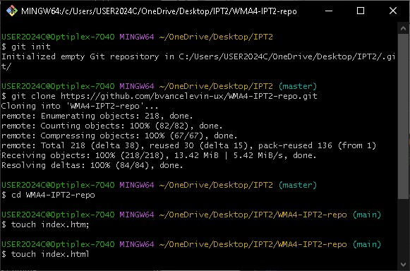

* Here I added the landing page file which is index.html clearly, I did the first landing page file at main without using a branch so after committng and pushing it to the remote repository I didn’t get to have a

pull request

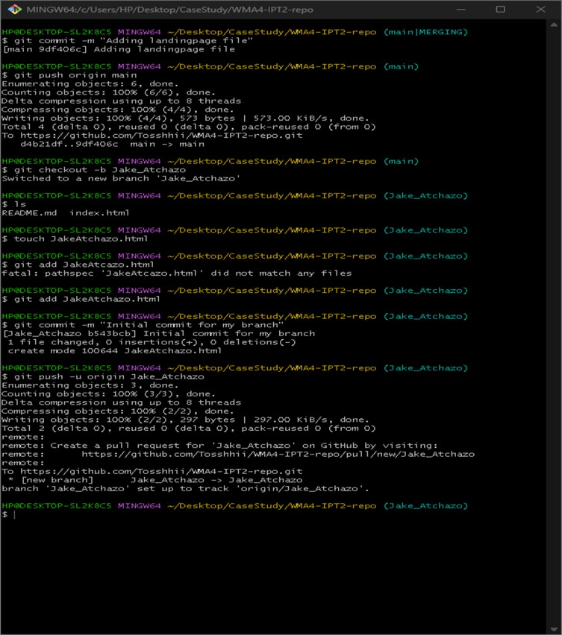

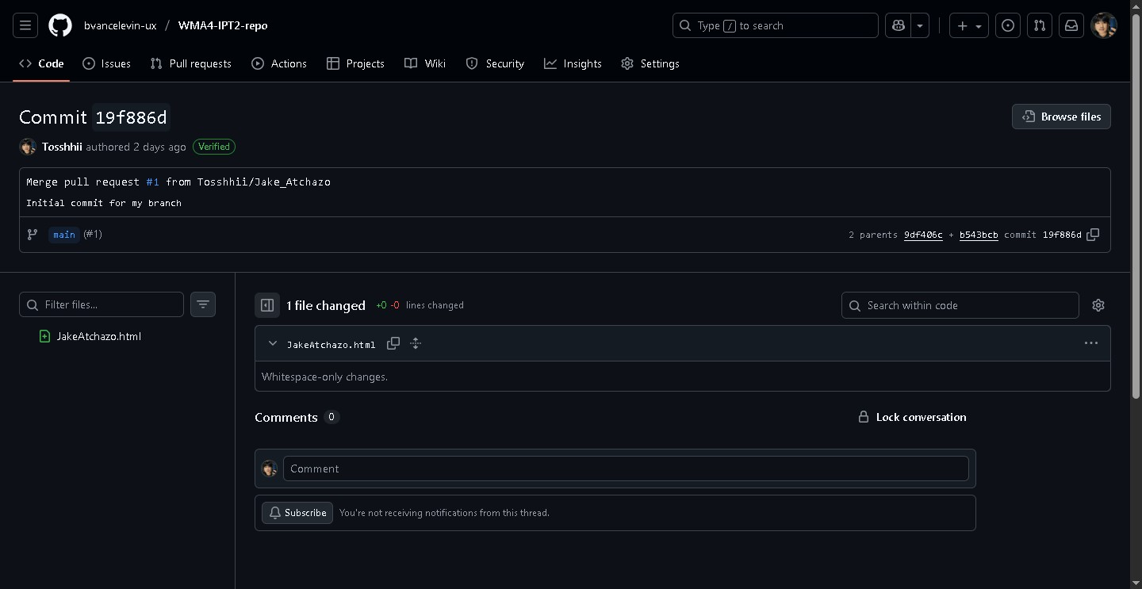

* This is after committing the initial file for the landing page at the main local to remote repository, I created a local branch using git checkout –b Jake_Atchazo which is the way to create a branch locally.

After that I added my initial file for my resume/portfolio website which is JakeAtchazo.html then committed my file, lastly I used git push –u origin Jake_Atchazo to push my local branch to the remote repository.

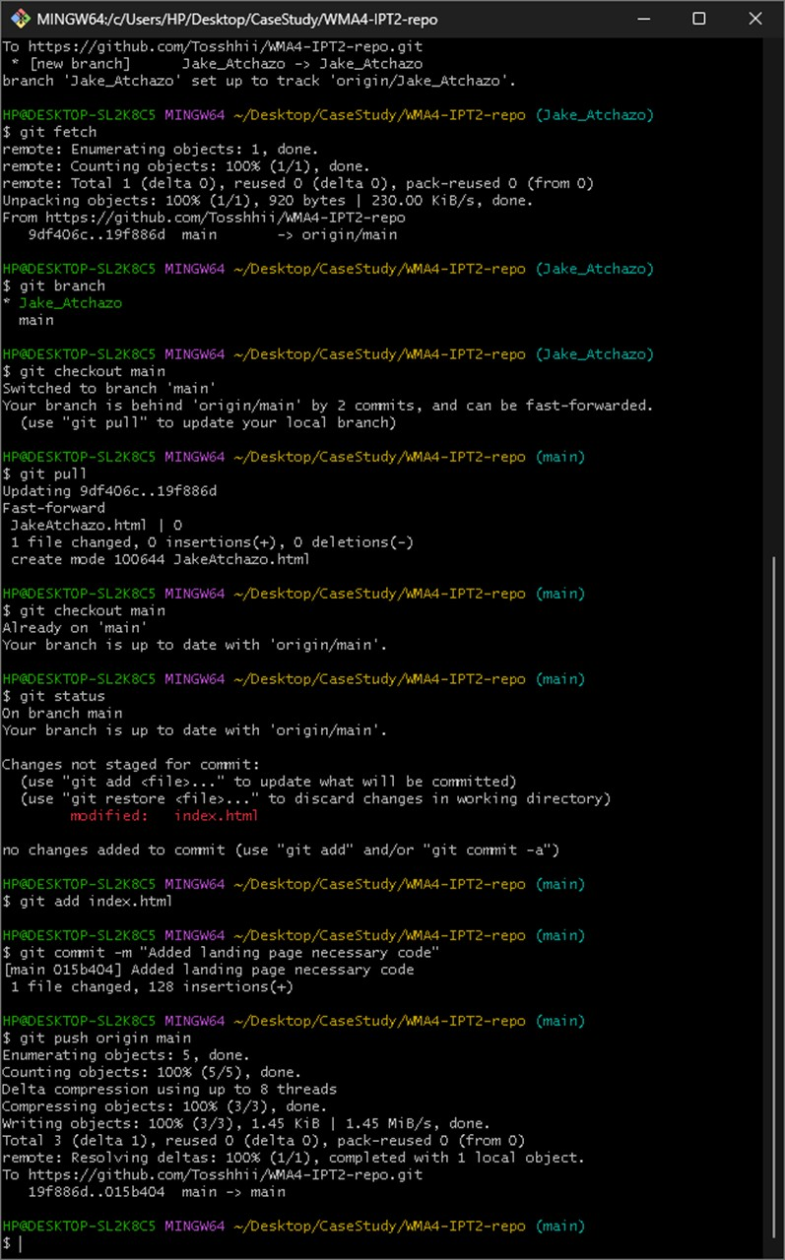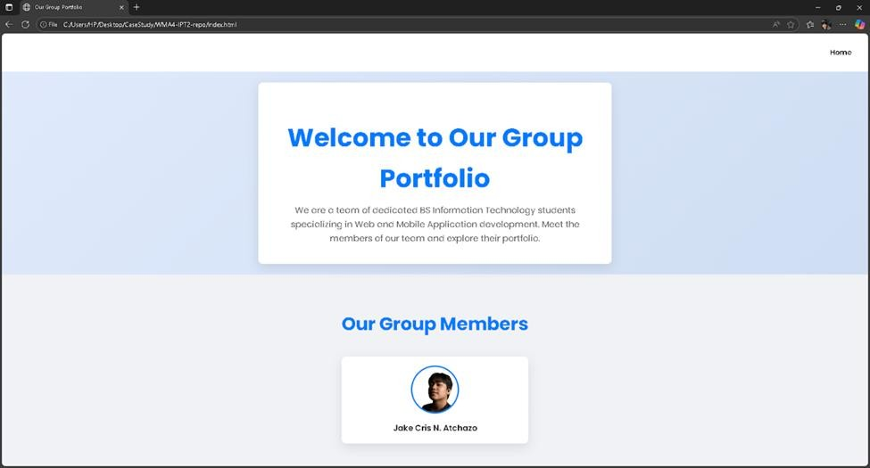

* Again, with the main branch I edited the index.html to add the necessary code for the landing page. I didn’t know that I was editing at the main branch at that time, so I blindly committed the changes and that move didn’t get to request for a pull request.

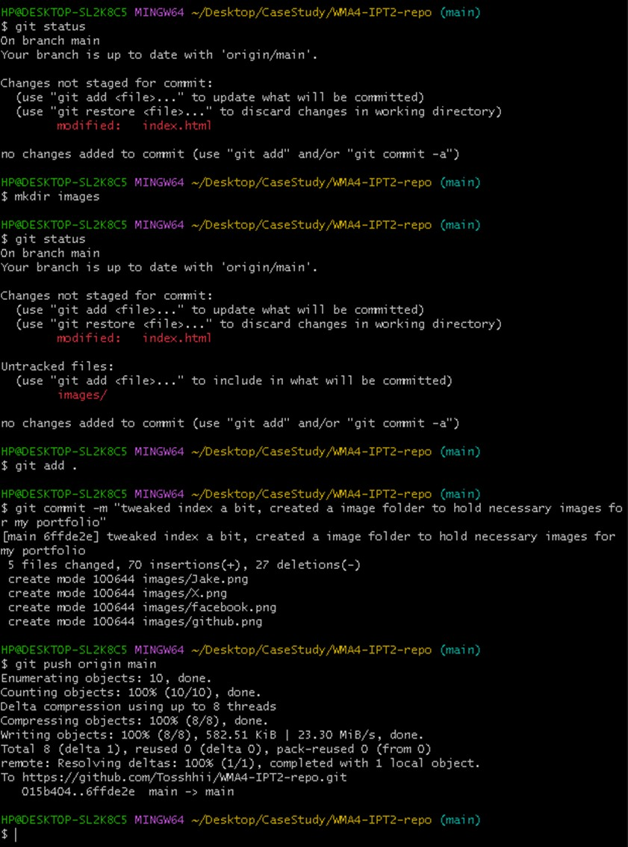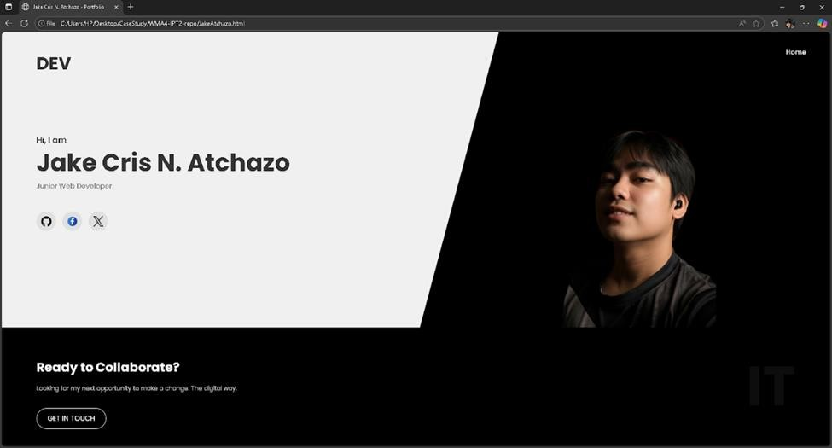

* Another one with a main push with so I didn’t get to have a pill request again this time, I added my initial design for the resume since at this time we still don’t have an agreed theme to follow. (Learning takes time)

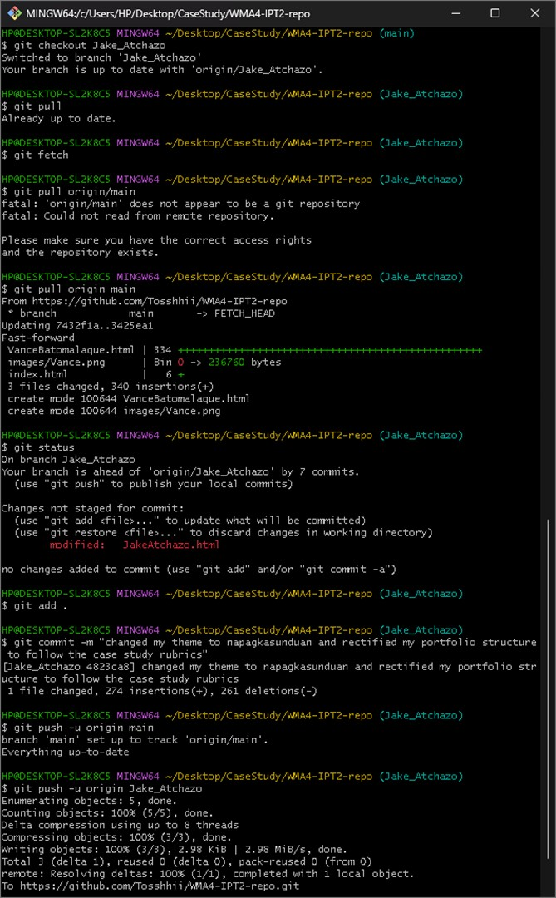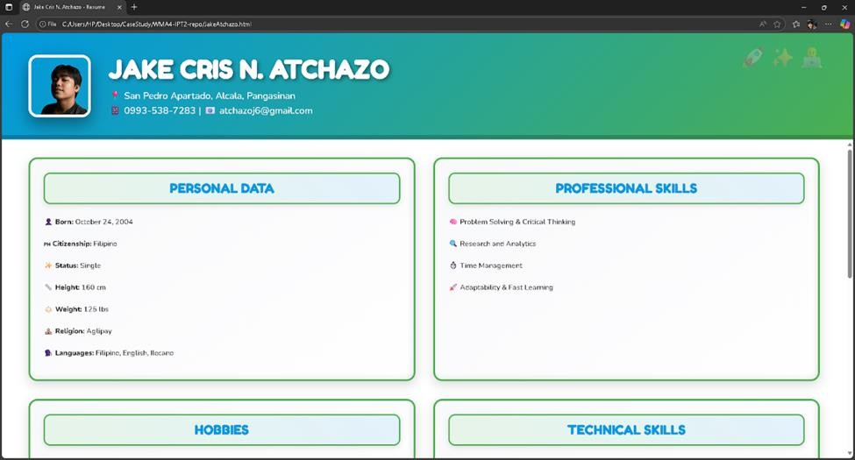

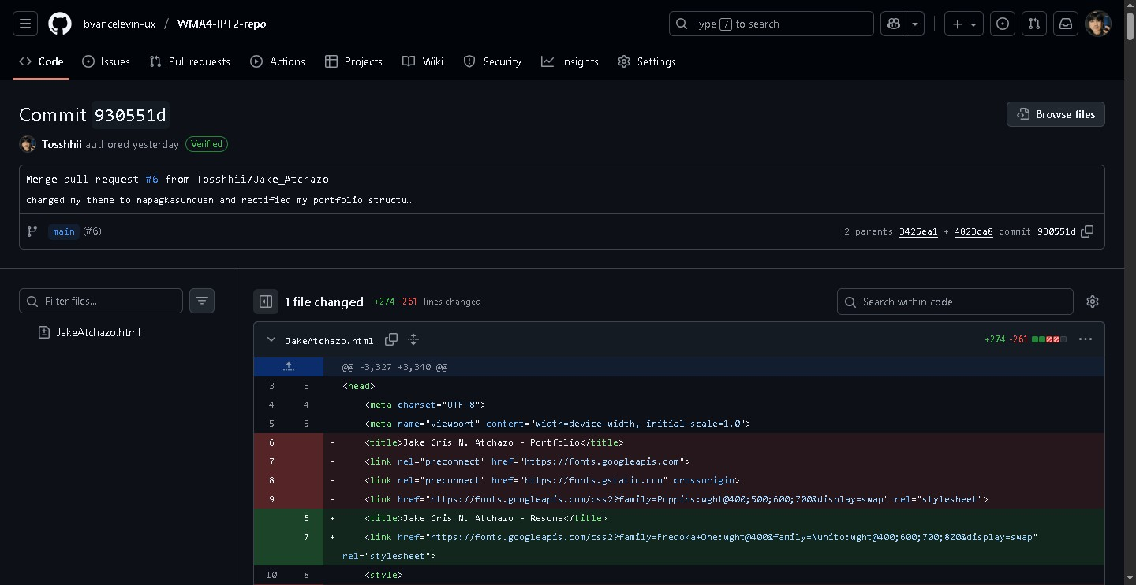

* This time I already learned my lessons and pushed through my branch to have that version control properly, I adjusted my theme to match our agreed theme and inserted my necessary info like a resume.

I used git pull origin main here to pull the file from remote main to make my branch have the updated files staged it and committed it then pushing it to remote branch of mine.

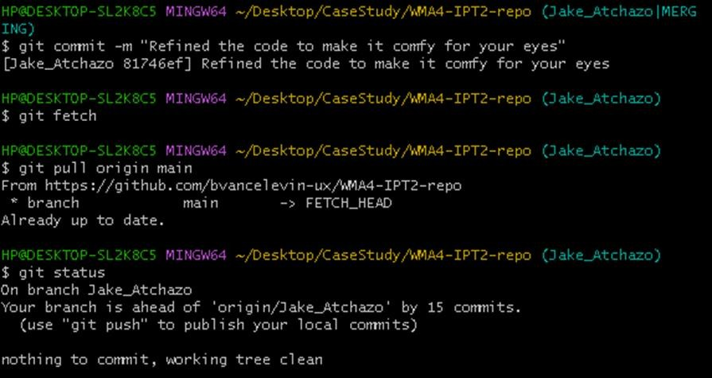 ps. I didn’t get to document the before of this since something happened when I tried to merge my local

main to my local branch probably cause by multiple pull request at that time

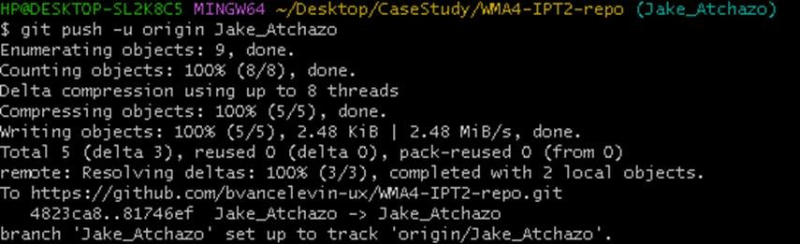

* Used git push –u origin Jake_Atchazo here to push my committed files to remote branch

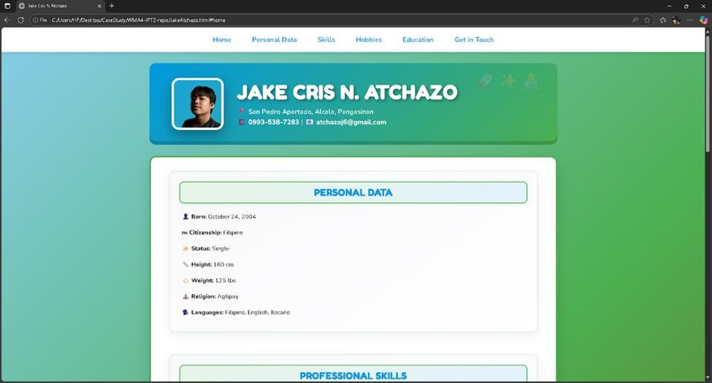

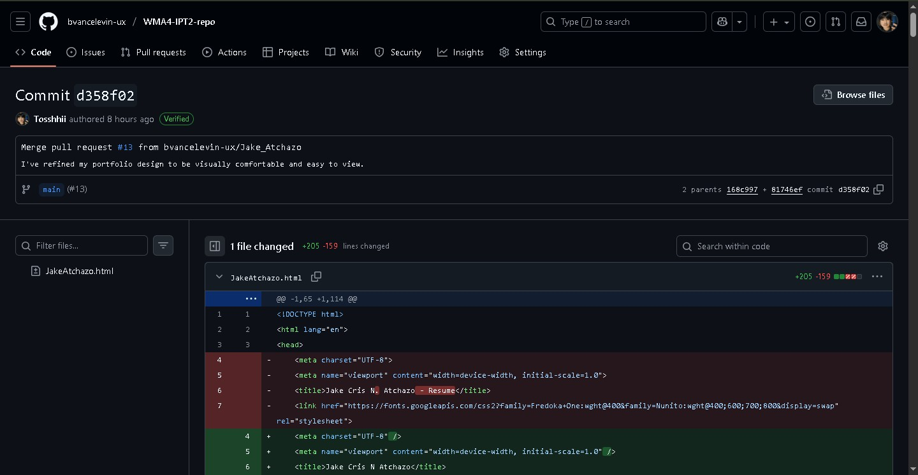

* This is the committed refined website of mine which I added a nav bar to match my groupmates that has a nav

bar on their website, as you can see the version was verified but didn’t get to snap that proof

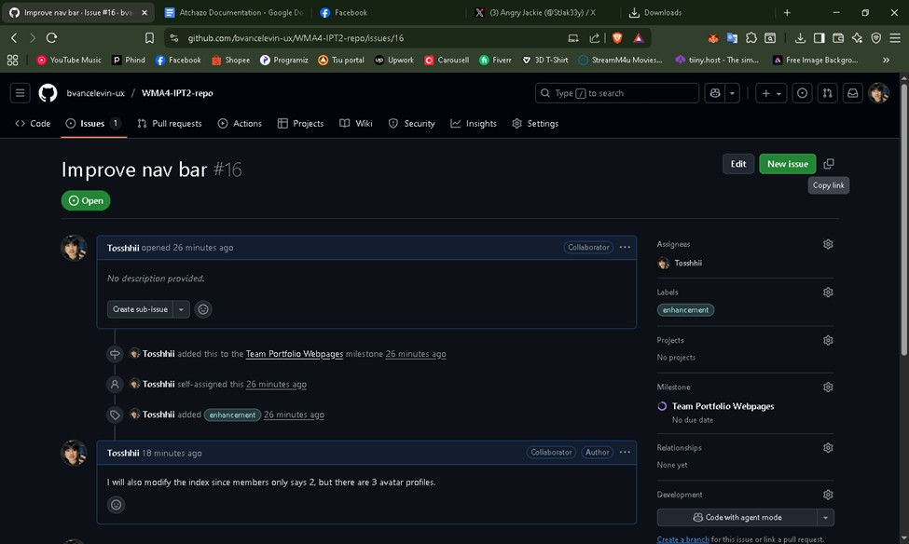

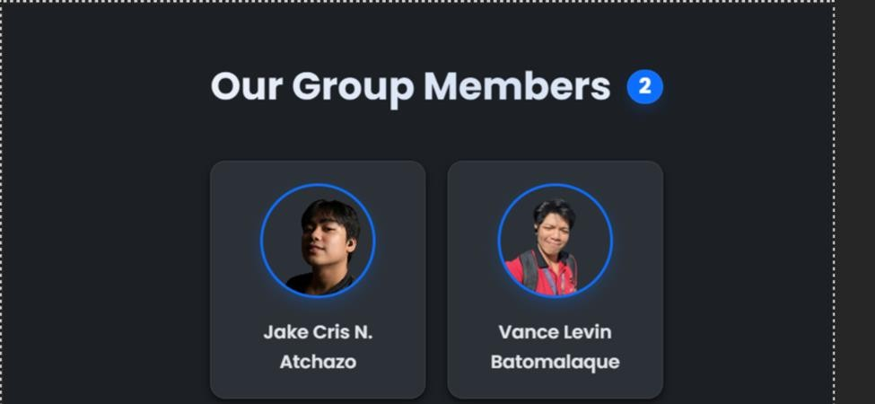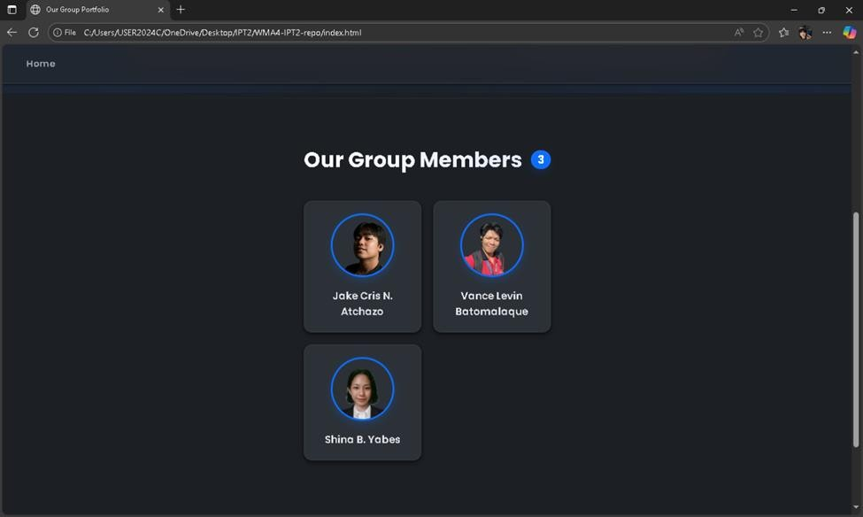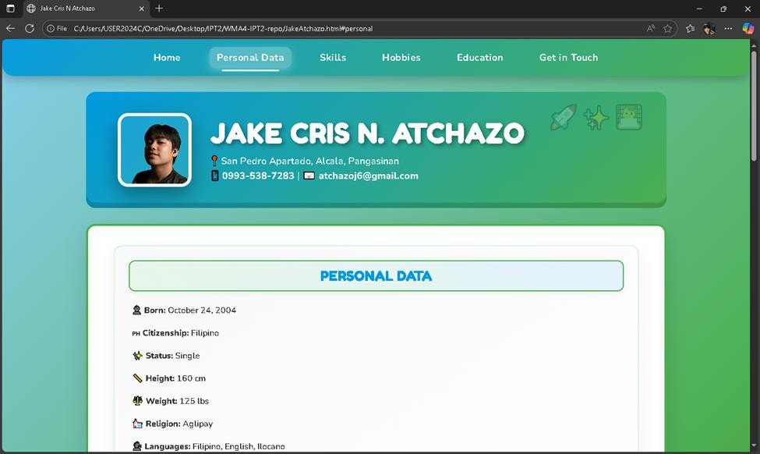

* I completed the issue that I assigned for myself here that is connected to the milestone from the repository but sadly another merging error occurred and this time I’m sure that it’s due to multiple pull request while I was busy fixing the issue regarding the pull request, sadly my branch file were uploaded directly to the main like this “git push origin main" or maybe from the commit since you are required to commit from fixing the Jake_Atchazo|Merging error without the files you modified being checked.[Again not documented properly since the terminal for the git bash opted for the no going back error.

## C. Case Analysis (Git and GitHub Workflow)

C.1 Batomalaque’s Documentation

1. Clone present github repo from Jake

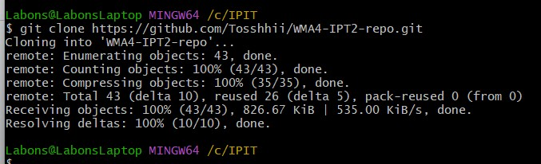

1. Use git pull to update just in case

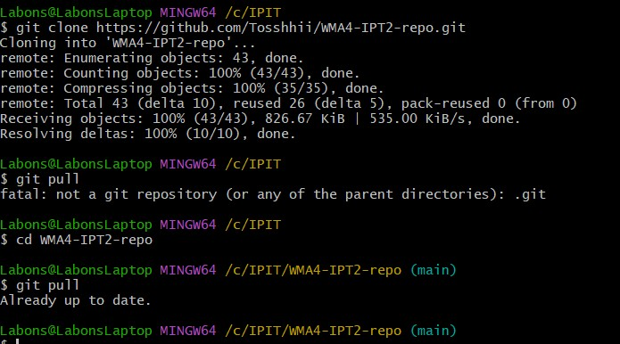

1. Create a branch to make progress on

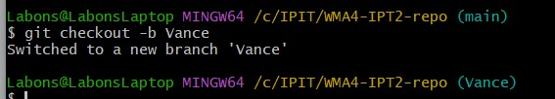

1. Create my own file for adaption of present design by Jake



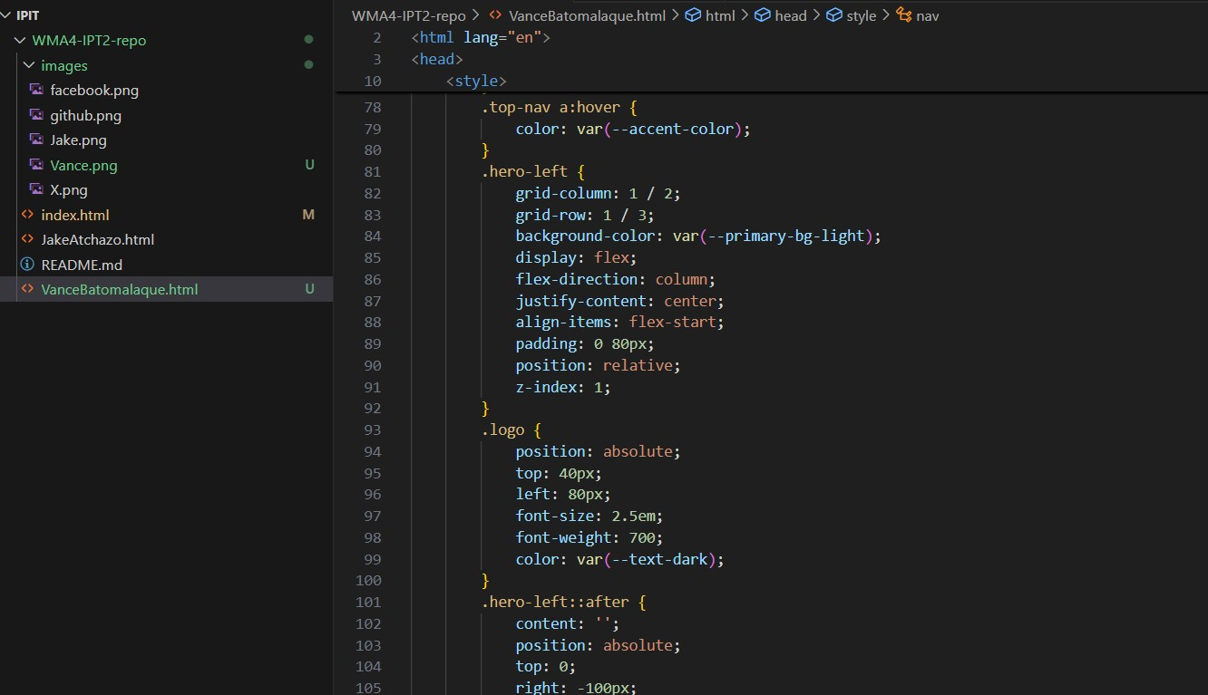

1. Added and committed to setup merge with main

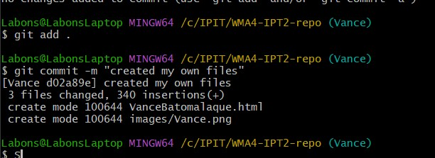

1. Merged with main

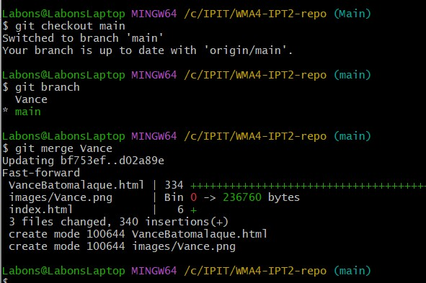

1. Made my own branch in github and pull to update

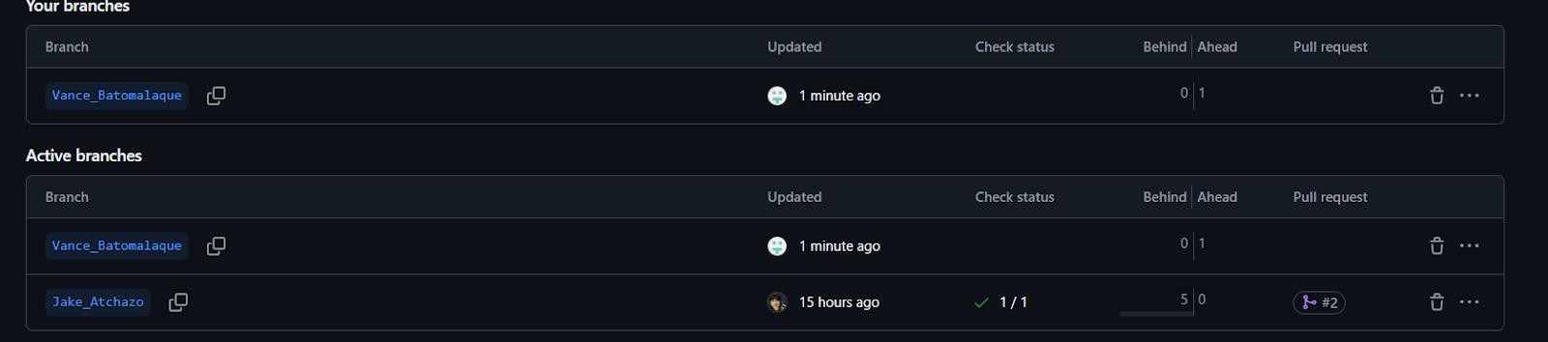

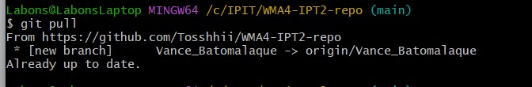

1. Pushed changes to New branch to create a pull request in github

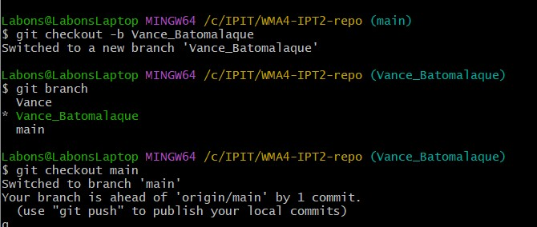

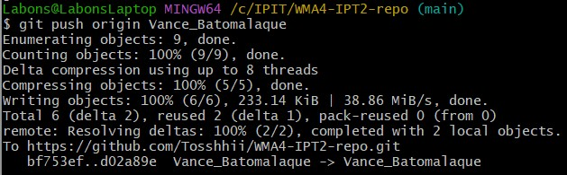

1. Creating Pull Request

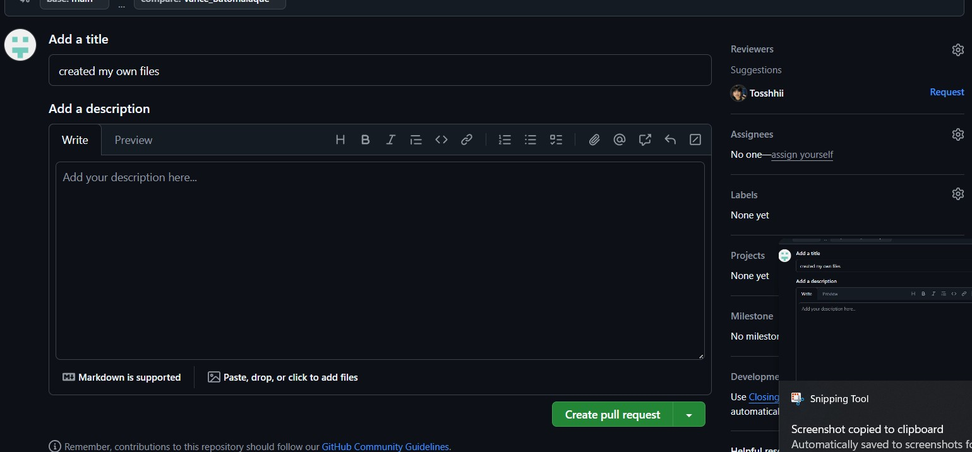

Forgot to change my windows credentials pala pero ako din po yan huhu Labons youtube.com/@labinbon870 :))

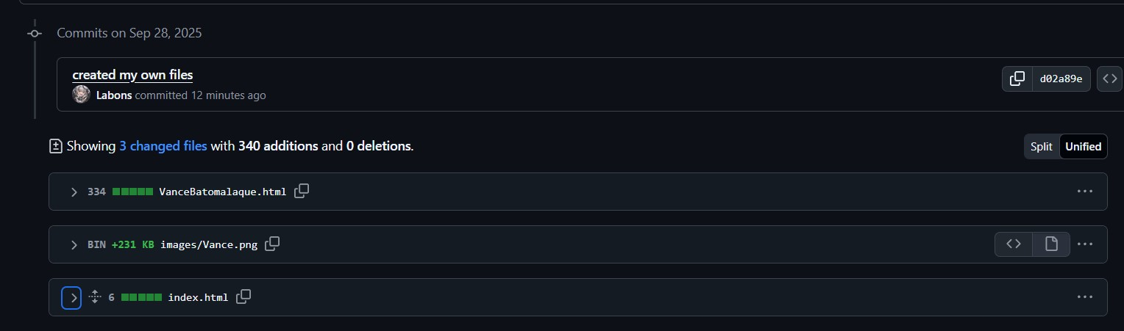

1. Auto merge dahil ako ang batas

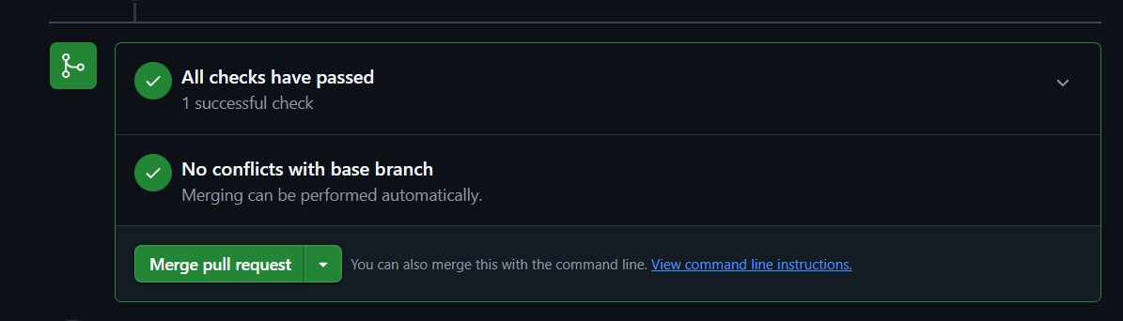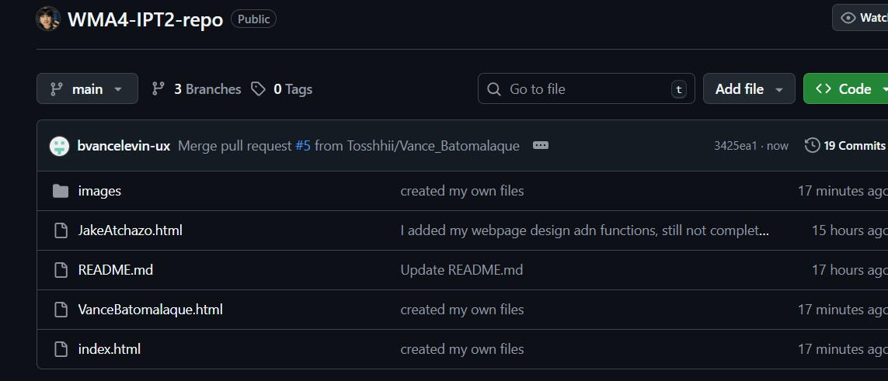

1. Adding progress to Landing Page

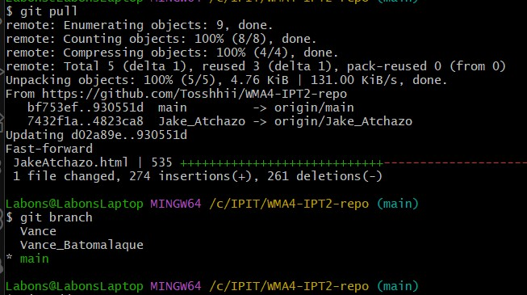

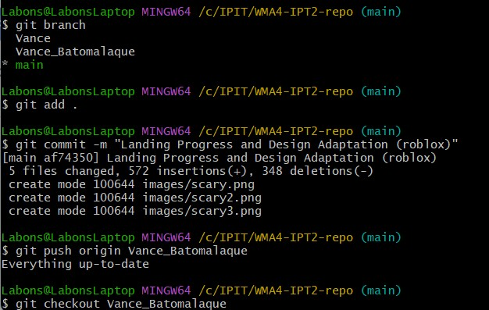

I messed up abit bcz i made the changes while i was in Main branch but I fixed it

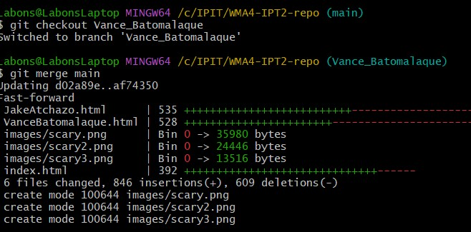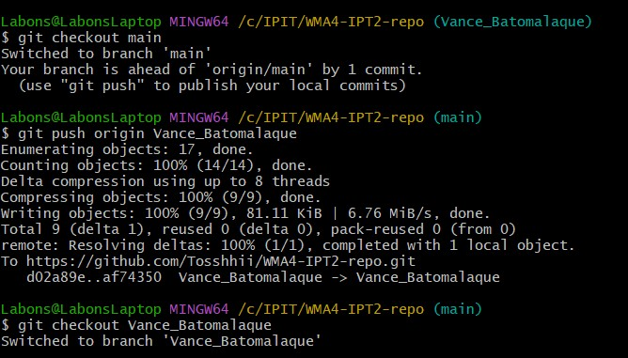

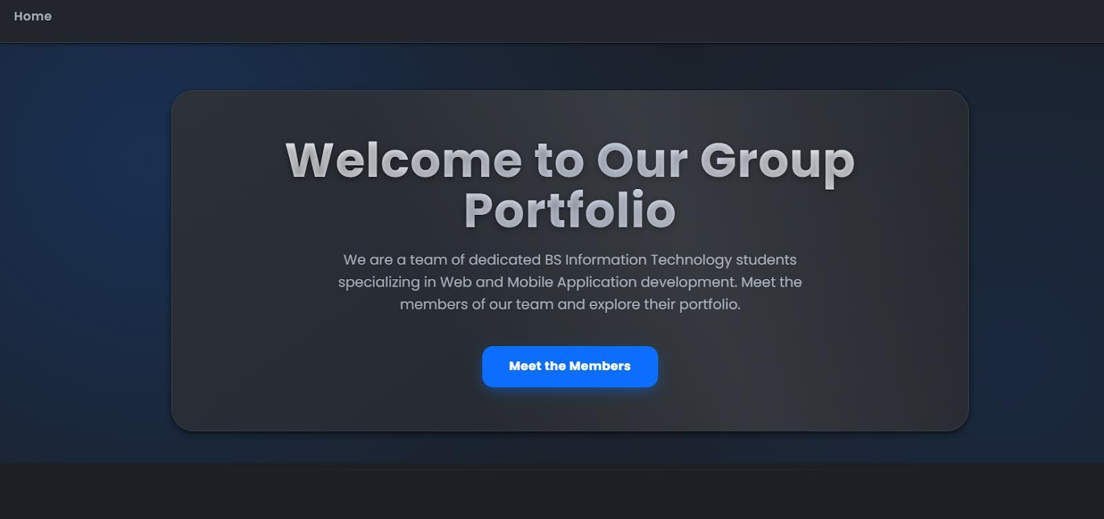

## D. Case Analysis (Git and GitHub Workflow)

D.1 Mina’s Documentation

**Setup the local repository**

* In desktop, I created my local repository.

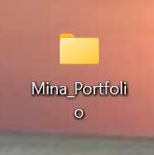

**etup the remote/connect to repo**

* Right click the folder and open gitbash.

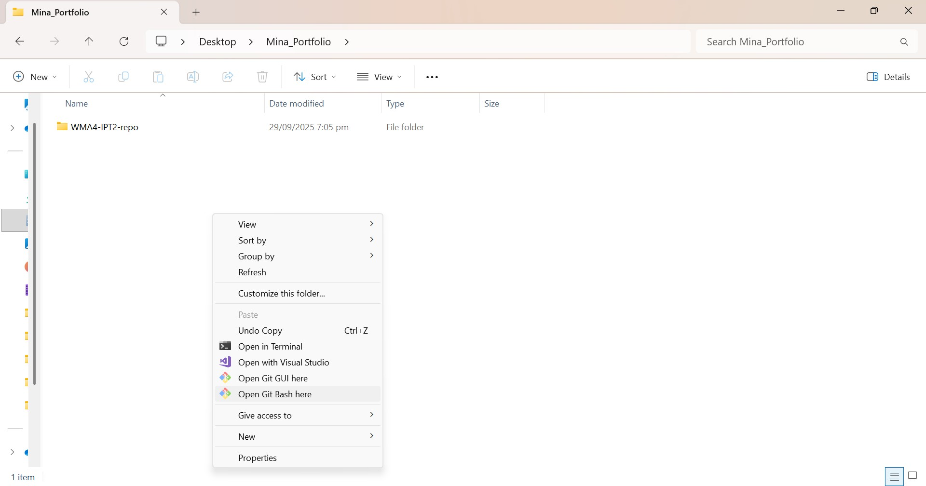

Using git init command, I initialized the local repository. And I download the remote repository using the git clone command and then access it.

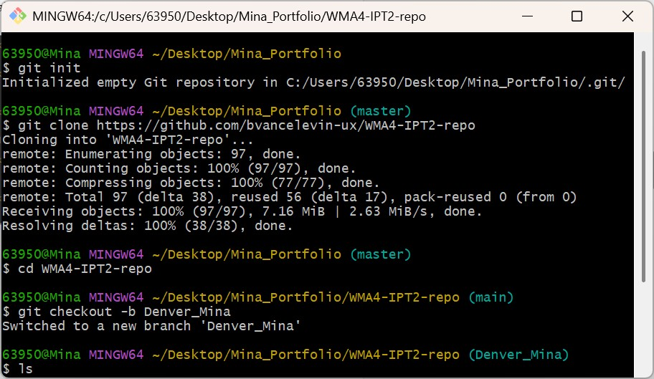

**Developing stage and using git and github as a version control system** Here shows that I developed using the VS code IDE.

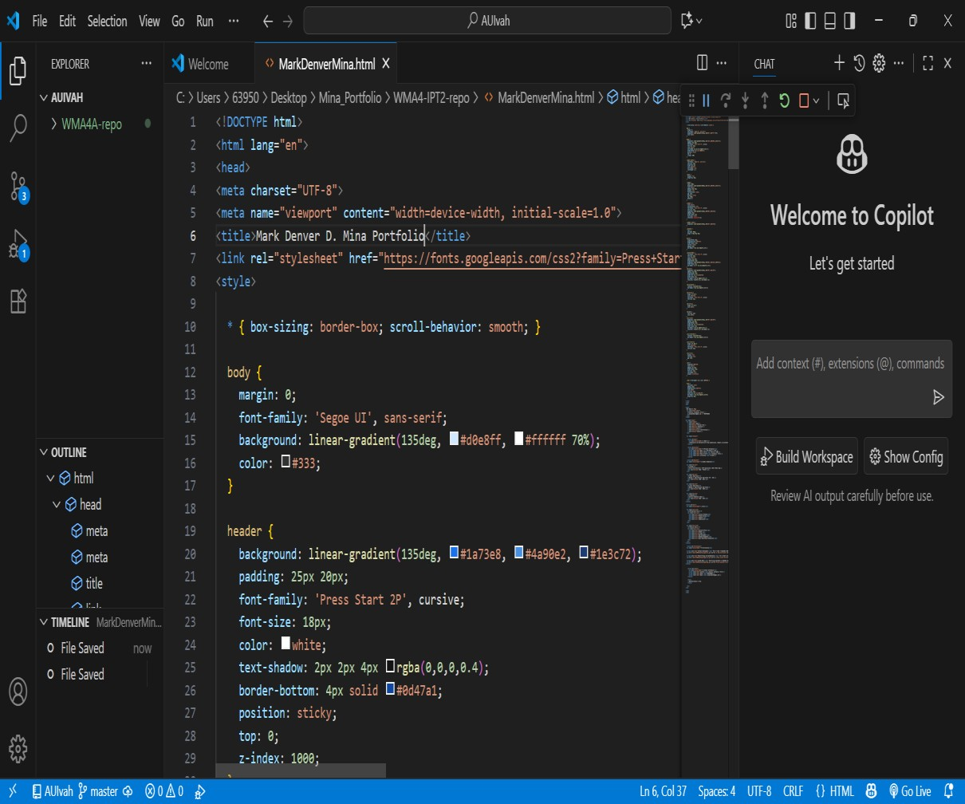

Here shows wherein I added my webpage in landing page.

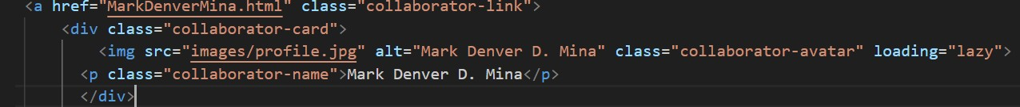

using git checkout -b i created my own branch named Denver_Mina. I created my html file using the touch command.

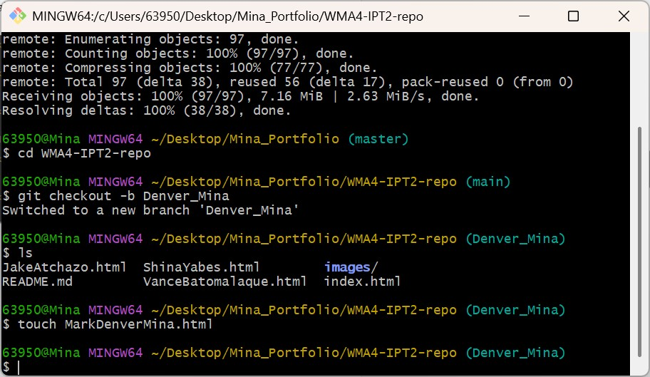

I staged my file using the git add command and make it tracked to be committed. And commit my file with a message using the git commit –m command then pushed it to my local repo using git push command.

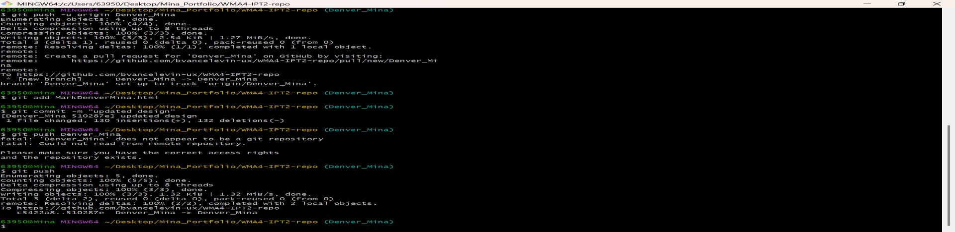

Here is just the same as the one above but now it's the index.html file for the landing page

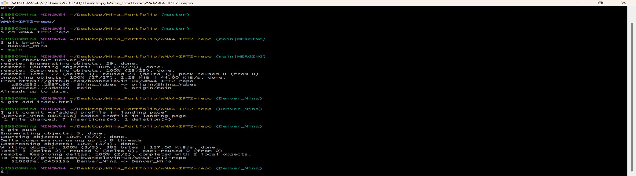

In github, I created a pull request.

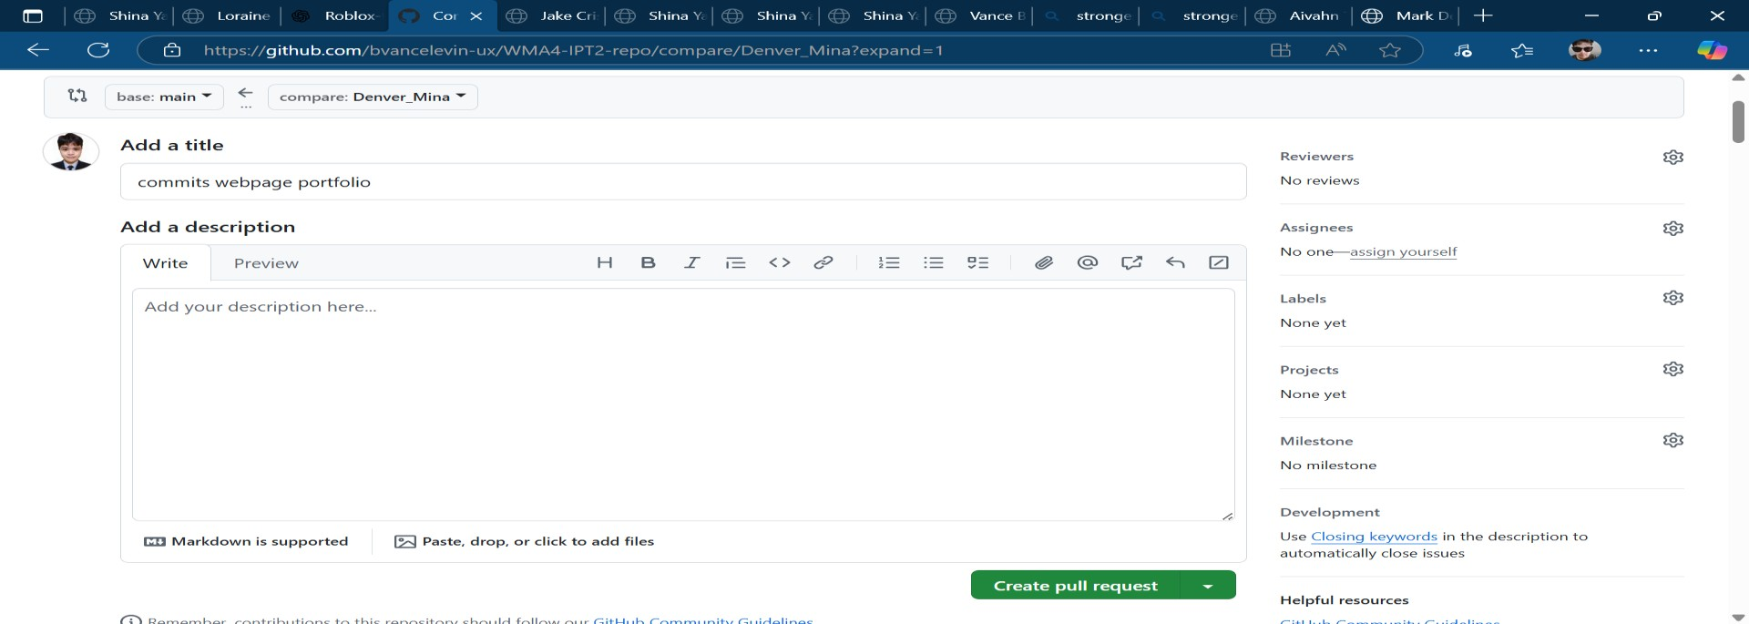

It shows here that I’ve committed and merge the files successfully to the remote repository.

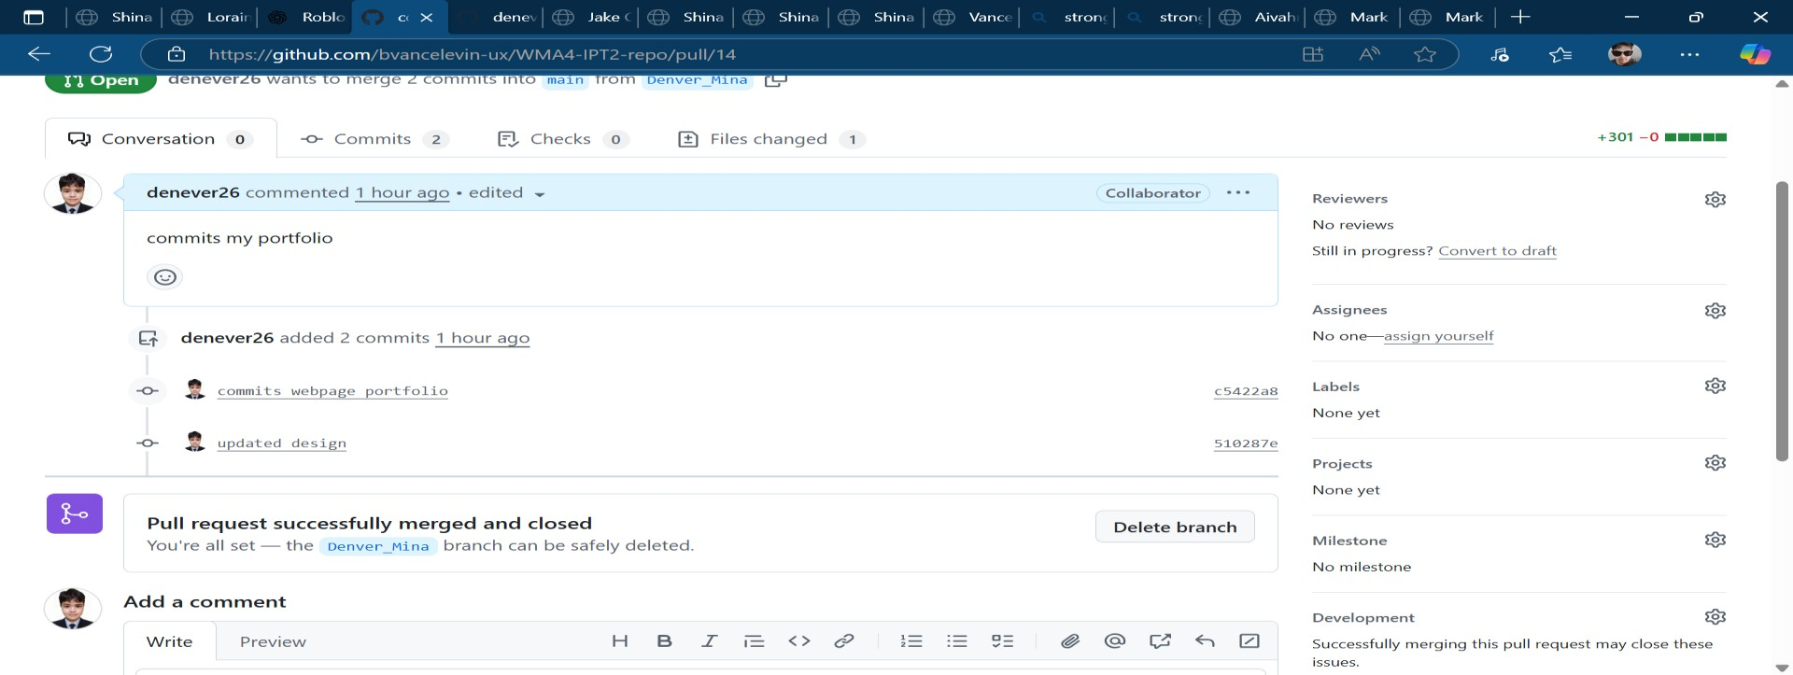

I created a task to be accomplished

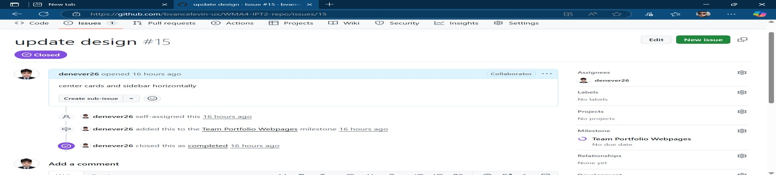

Here shows the comparison of the before and after of the design.

Before

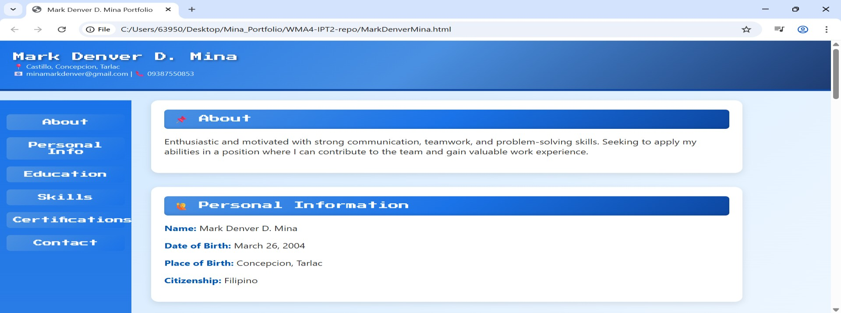

After

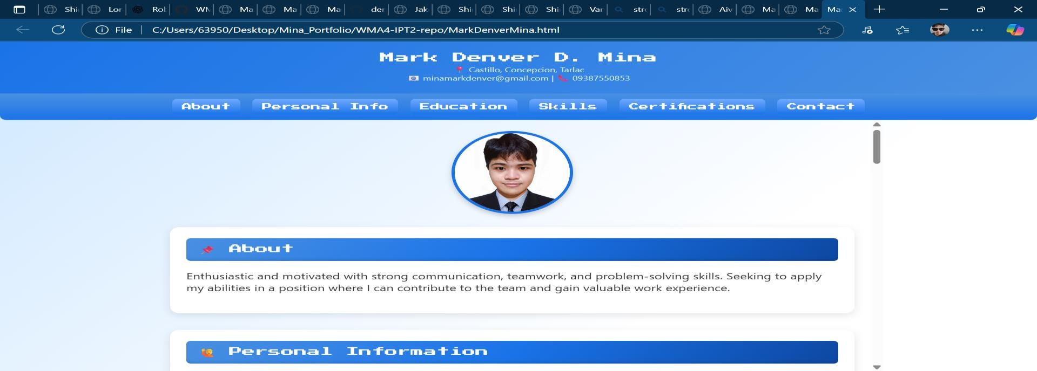

Here shows that I’ve successfully added my profile on landing page.

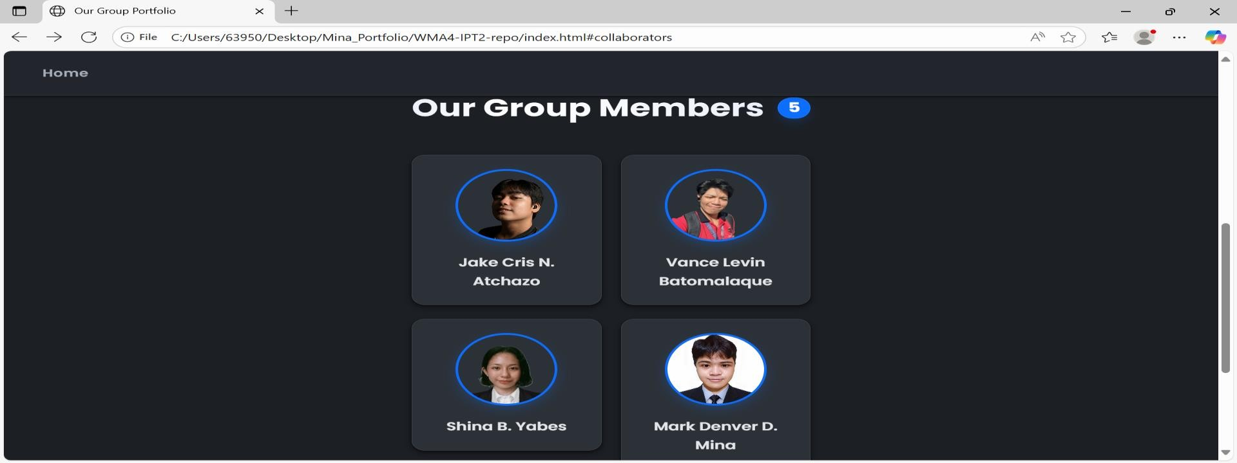

Here shows milestones of the teams wherein the issues are accomplished

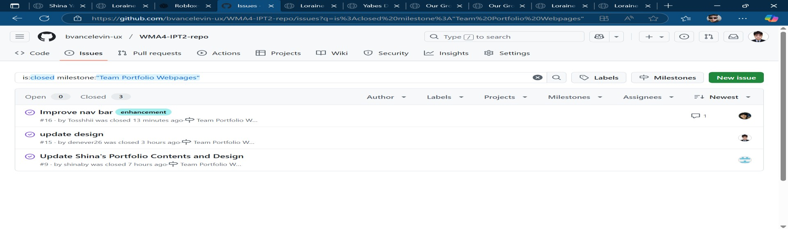

## E. Case Analysis (Git and GitHub Workflow)

E.1 Rodrigueza’s Documentation

* I began by cloning our group repository from GitHub to my local computer via the git clone command. This provided me with a functional local copy of our project.

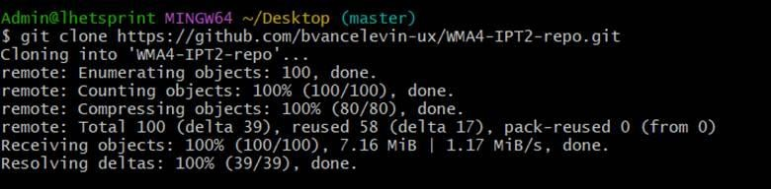

* I changed into the directory of the cloned repository so that I could work within it.

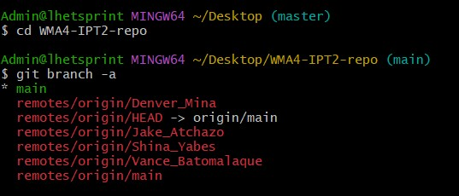

* To prevent directly editing on main, I created my own branch, Loraine_Rodrigueza.

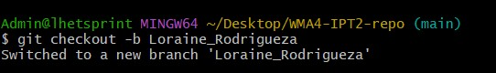

* Here, I made my personal portfolio webpage file.

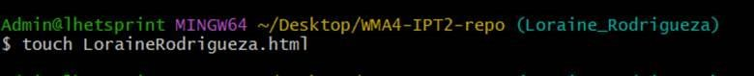

* Next, I formatted it in VS Code using my HTML/CSS/JAVASCRIPT layout.

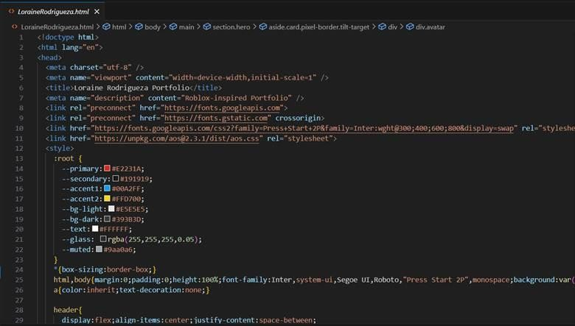

* I edited index.html to include a link to my portfolio so it could be accessed from the landing page.

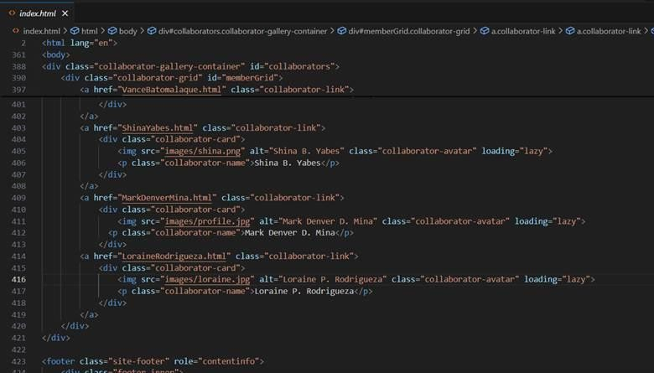

* I staged my files so Git would track them for the next commit.

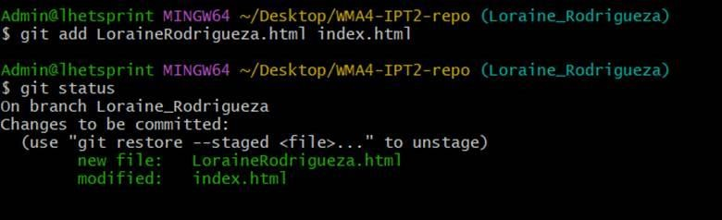

* I saved my work in Git’s history with a descriptive message.

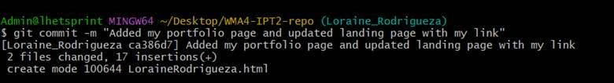

* In order to share my work with the team, I pushed my branch to the remote repository.

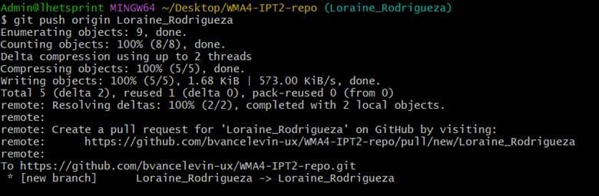

* On GitHub, I opened a Pull Request to merge my branch into main.

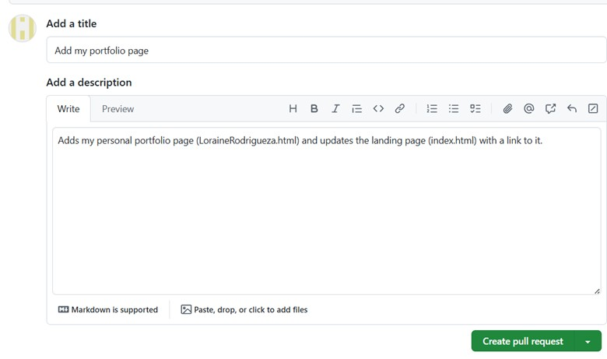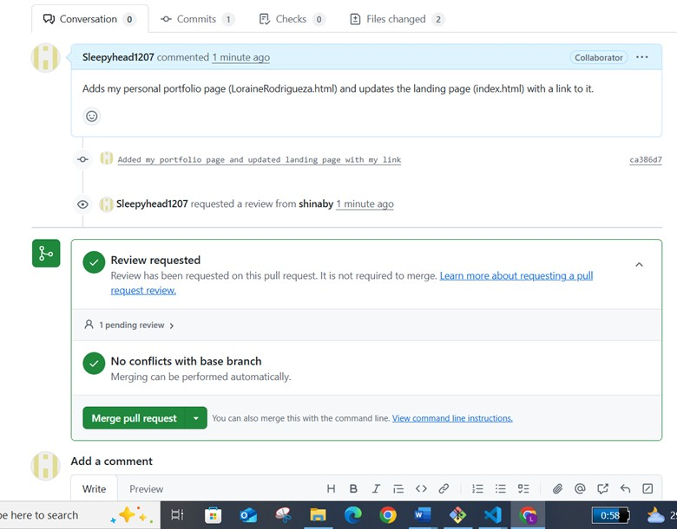

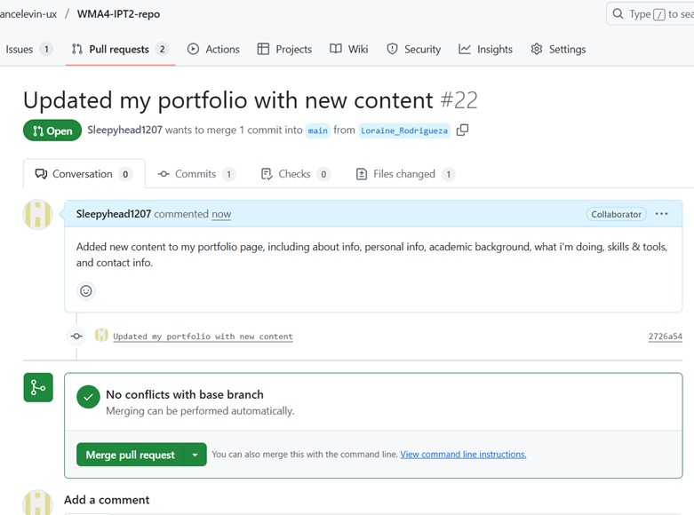

* I created a GitHub **Issue** titled *“Loraine Portfolio Page”* to track my task.

I then linked it to our group Milestone *“Team Portfolio Webpages”* for progress monitoring.

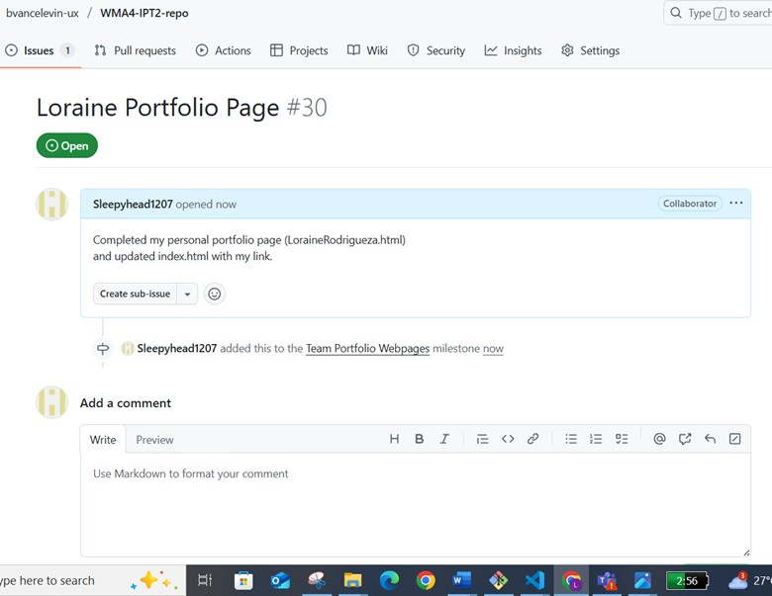

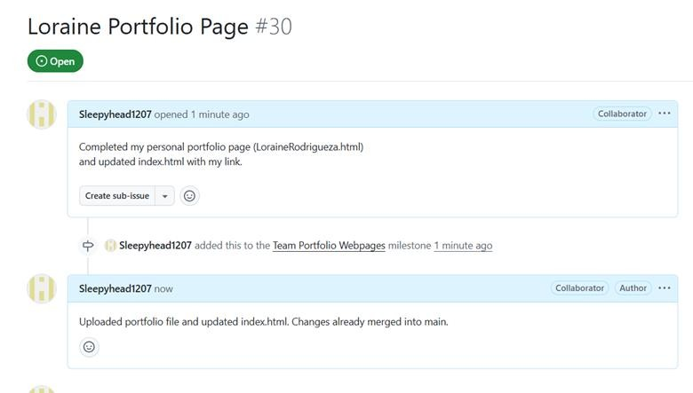

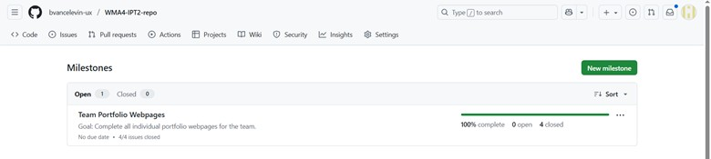

• Lastly, I synced my local repo to include the merged changes.

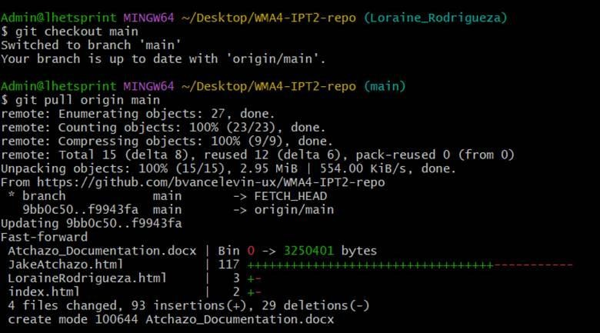

## F. Case Analysis (Git and GitHub Workflow)

F.1 Yabes’s Documentation

* **Accessing and creating a local repository folder.**

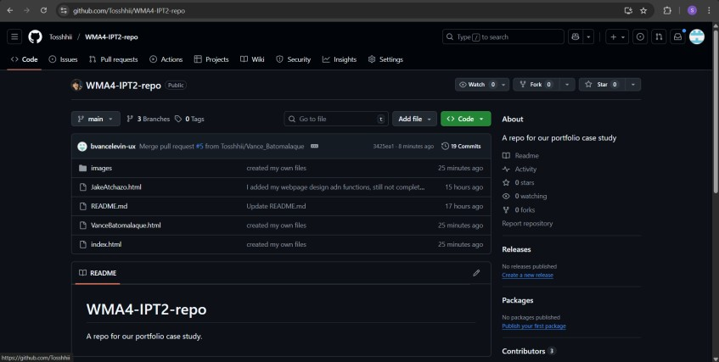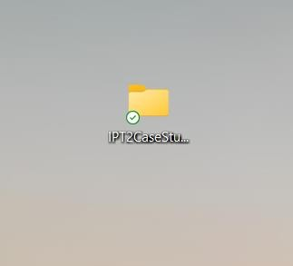

* **Connecting to the remote repository -** Cloned the team repository from GitHub using git clone.



* **Created a branch and initial file –** Created my own branch Shina_Yabes using git checkout -b Shina_Yabes. Added an initial HTML file ShinaYabes.html as my portfolio page.

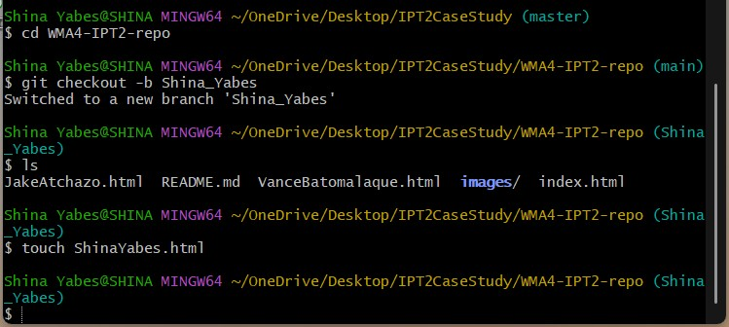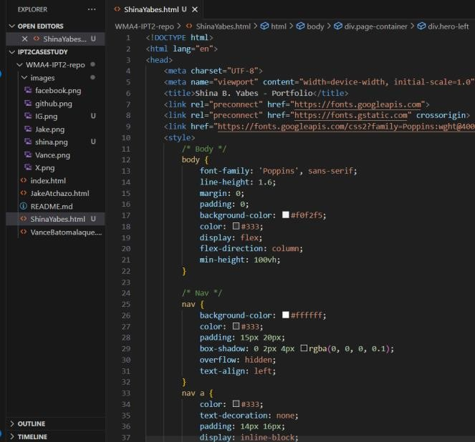

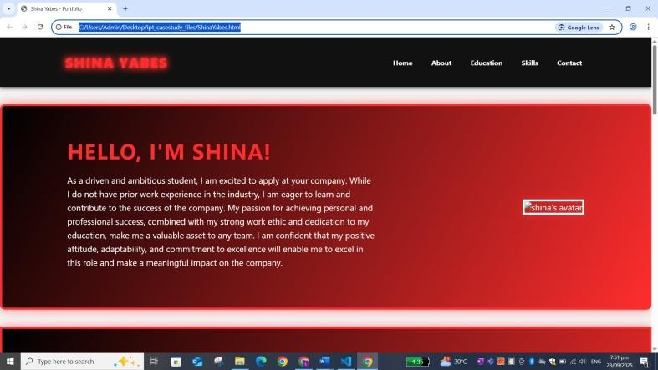

* **Pushed and merged the initial file –** Committed the initial file using git add and git commit. Pushed the branch to GitHub with git push -u origin Shina_Yabes and created a Pull Request to merge into main.

•

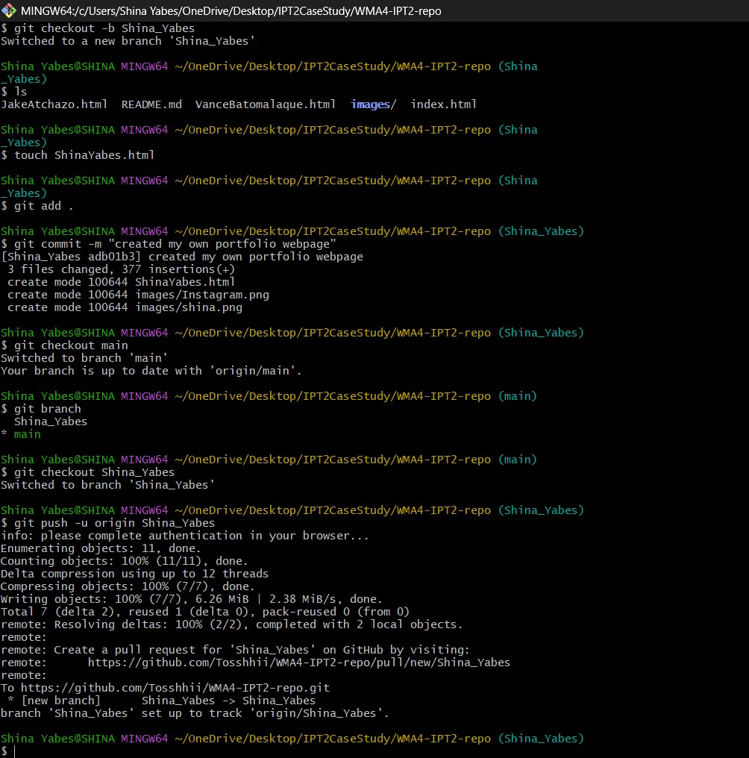

* **Created an Issue and linked it to a Milestone on GitHub – Created an Issue to track my task. Linked the Issue to the team Milestone “Team Portfolio Website” to monitor progress.**



* **Updated file (updated content and design, dahil masakit daw sa eyes)** – Edited ShinaYabes.html to improve content and design.

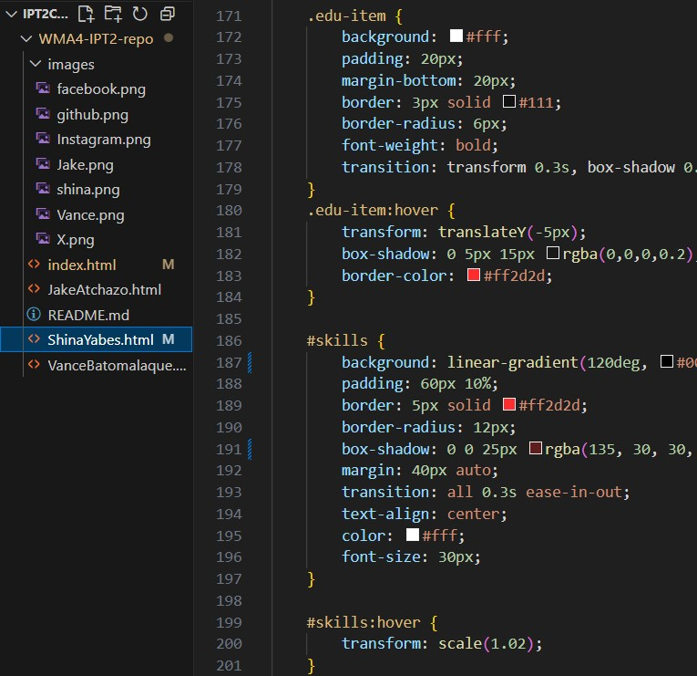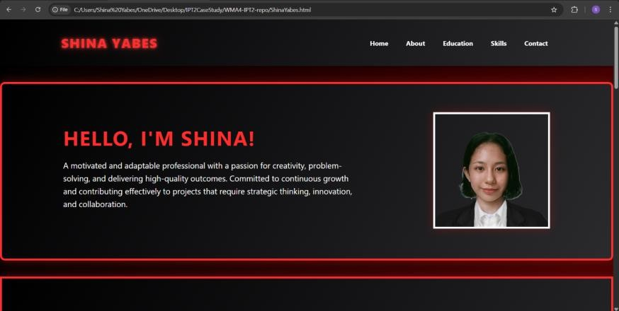

* **Pushed and merged the updated file – After finalizing my webpage, I s**taged and committed the changes using git add and git commit. Pushed the updated branch to GitHub and merged it into main via Pull Request. I also closed my issue on GitHub after updating my webpage.

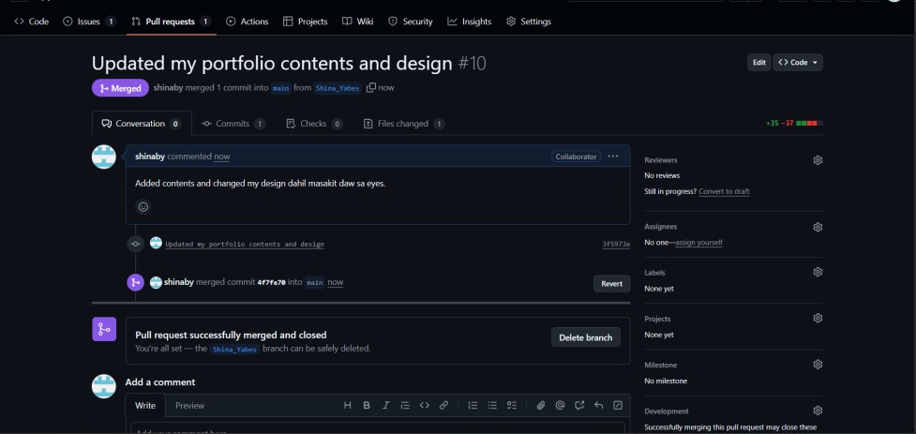

* **Accessed the team’s home page file to add my profile landing page –** Opened index.html and added a section linking to my portfolio page. Committed, pushed, and merged the changes following the same Git workflow.

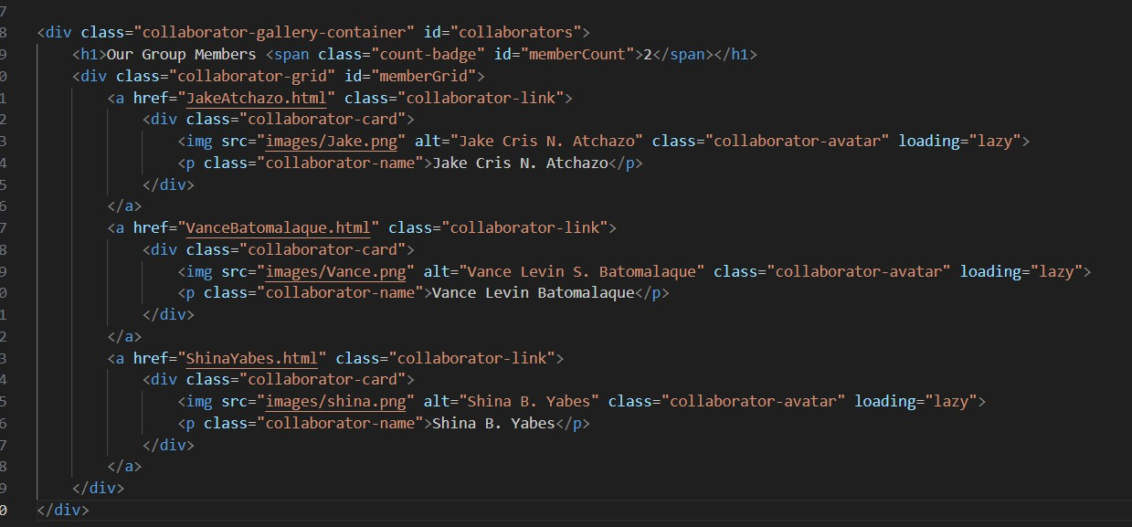

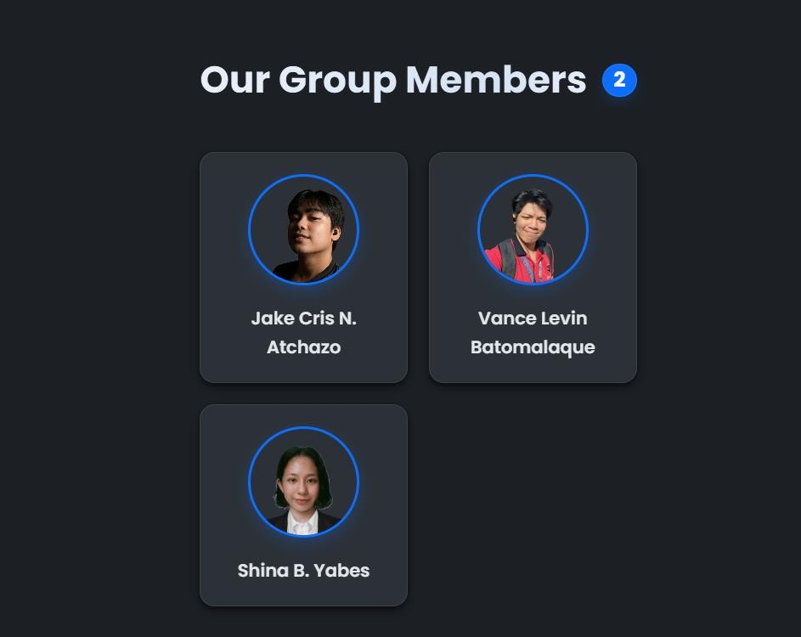

* **Pushed and merged the updated file –** Staged and committed the changes using git add and git commit. Pushed the updated branch to GitHub and merged it into main via Pull Request.

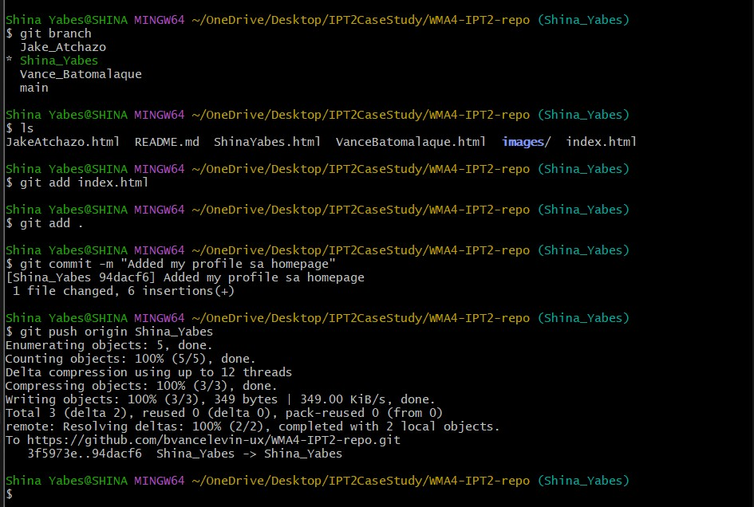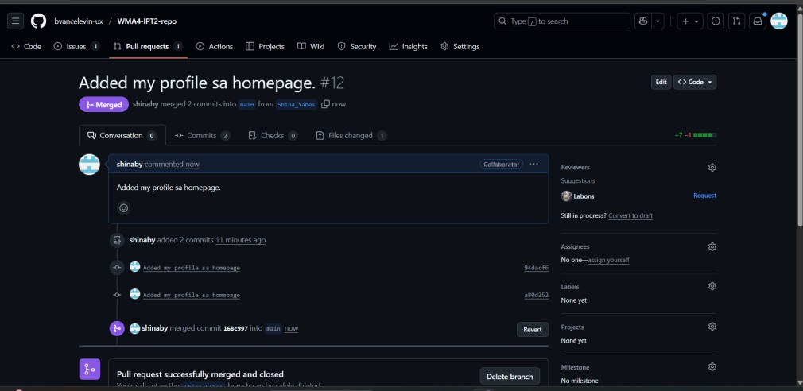

## G. Individual HTML

**index.html**

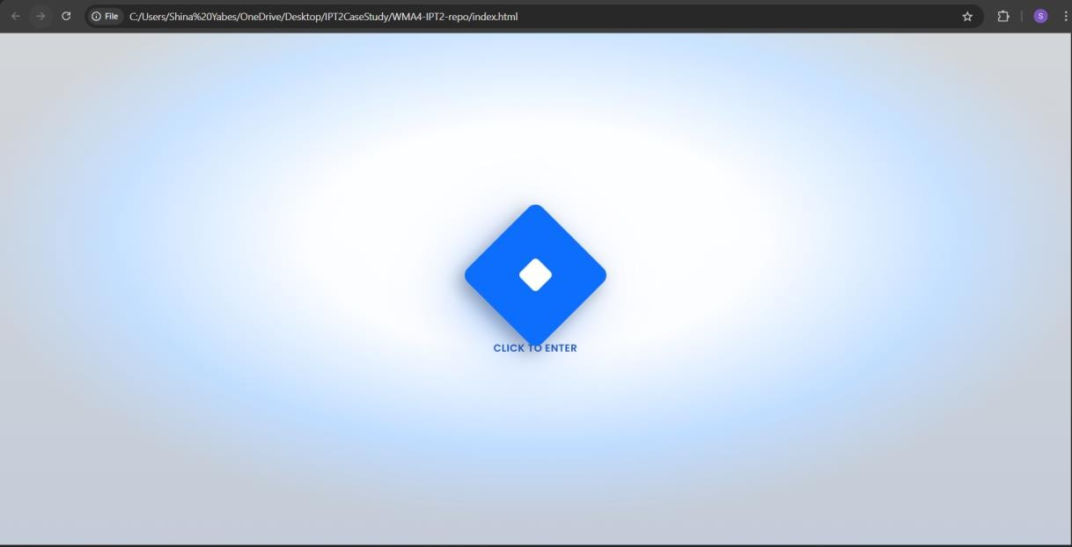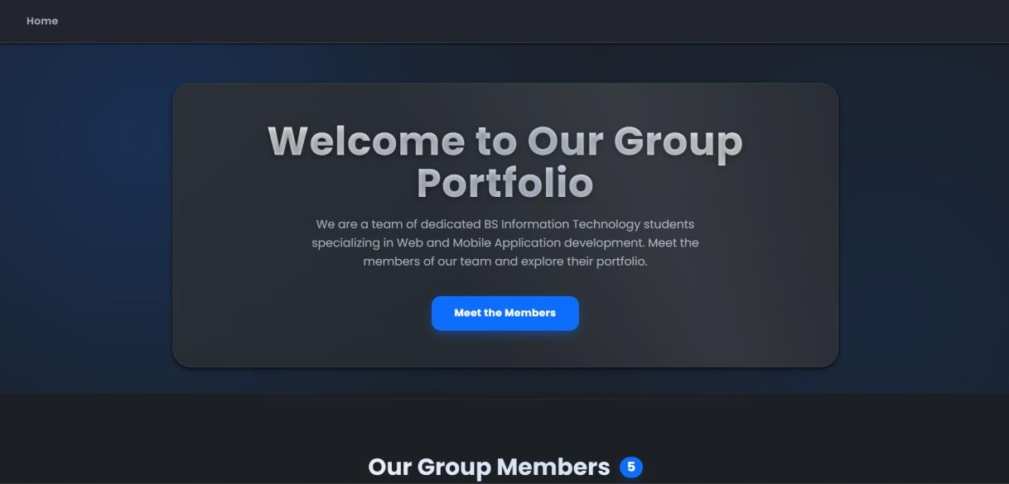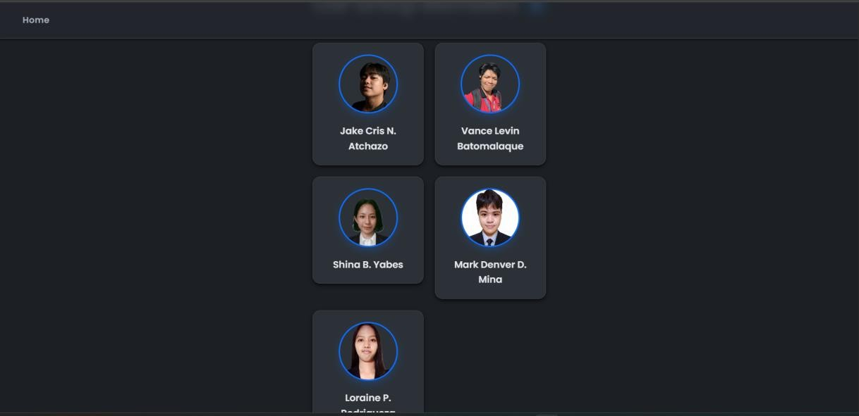

**JakeAtchzo.html**

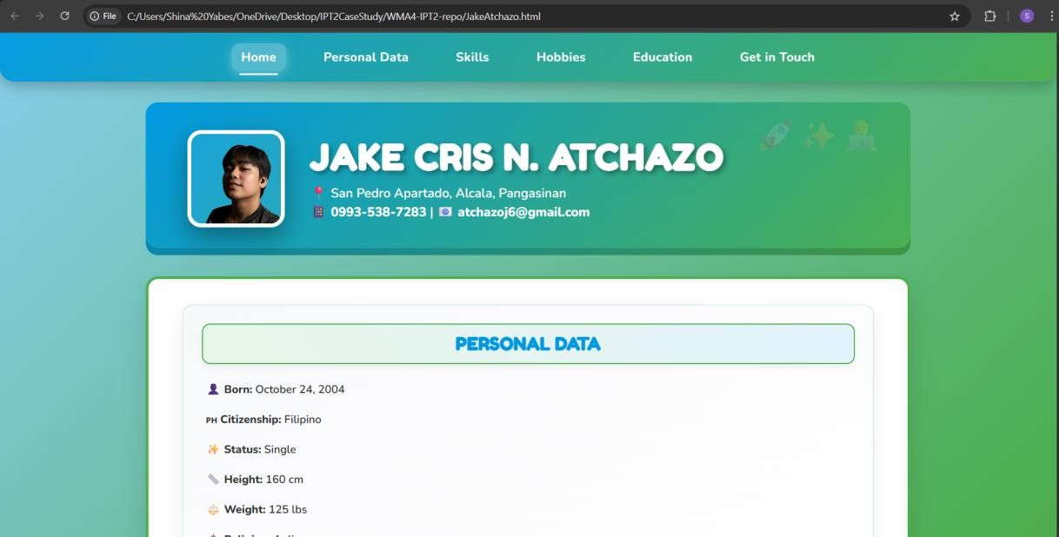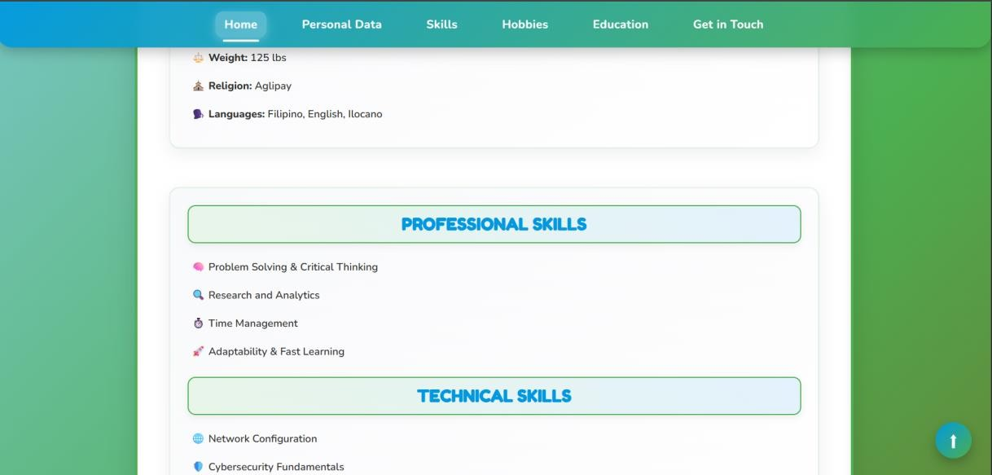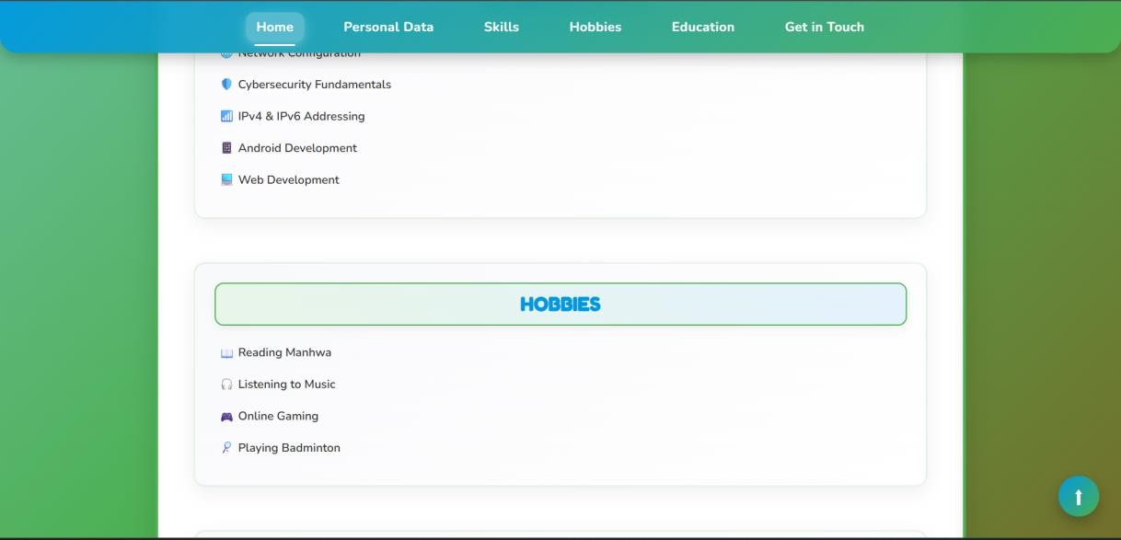

**VanceBatomalaque.html**

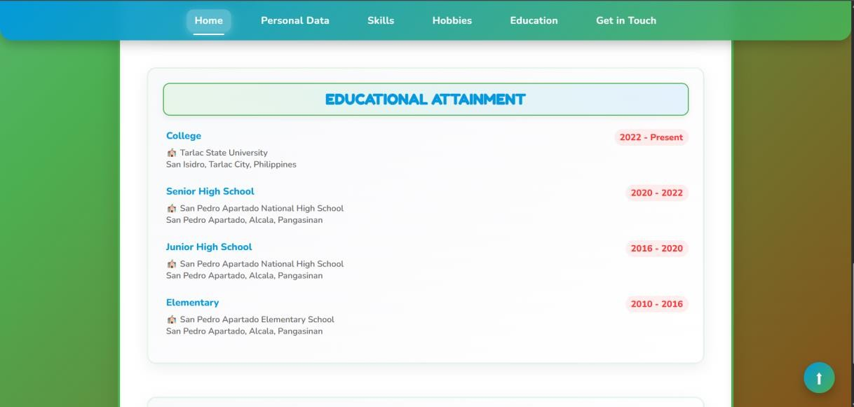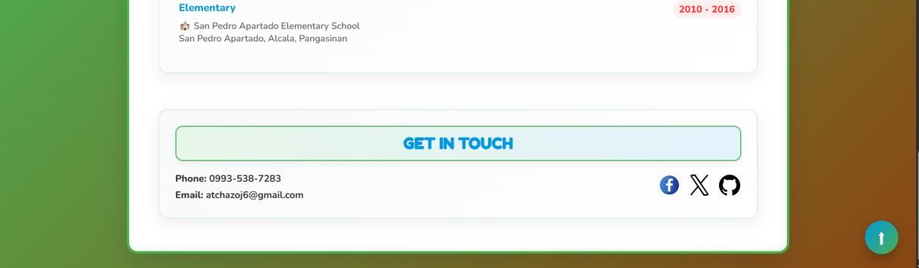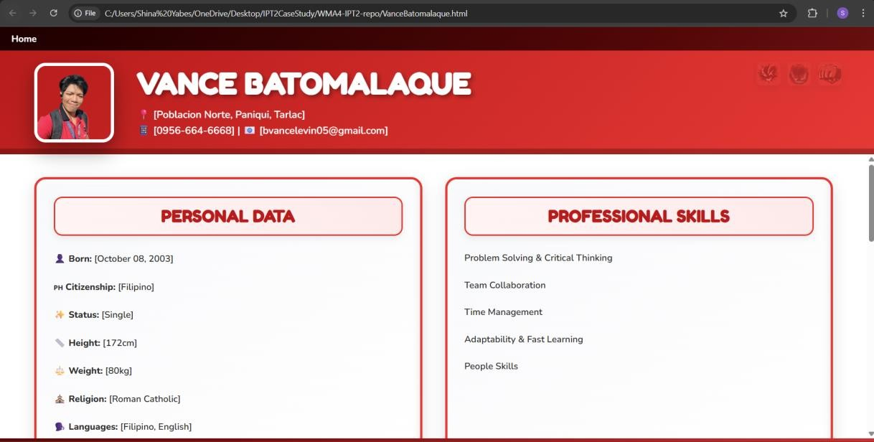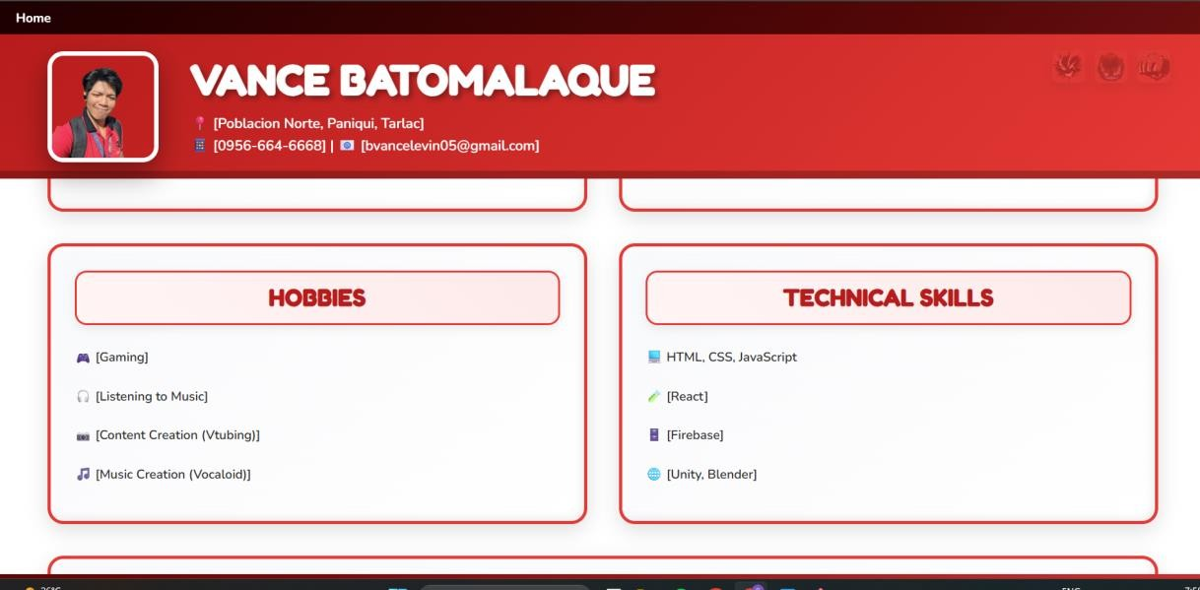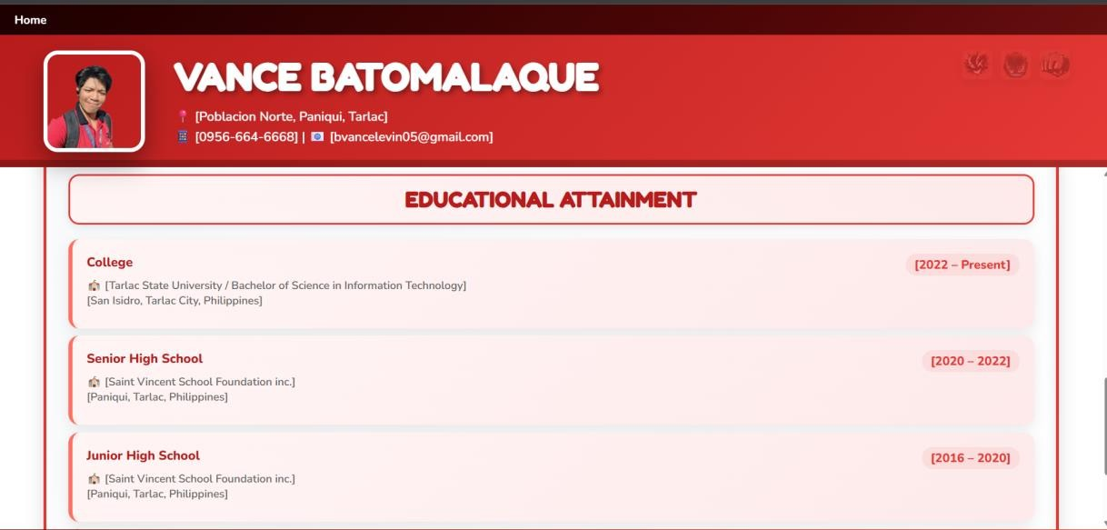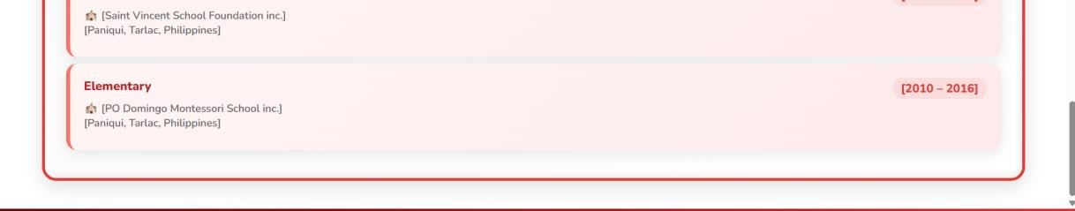

|  |
| --- |
| MarkDenverMina.html |
|  |

|  |
| --- |
|  |
|  |
|  |
|  |
|  |
|  |

**LoraineRodrigueza.html**

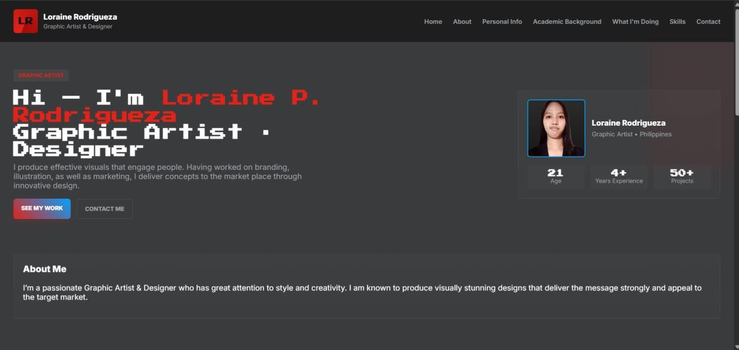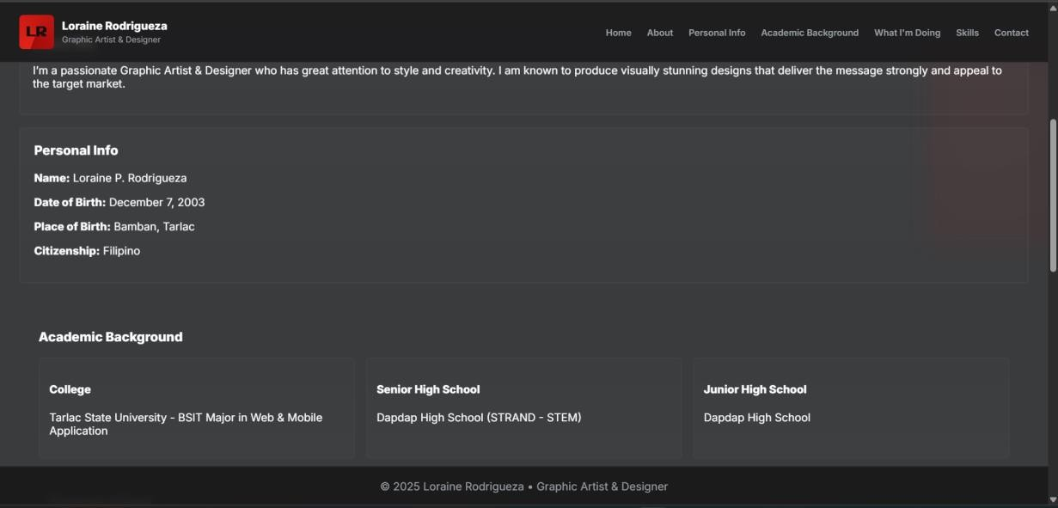

**ShinaYabes.html**

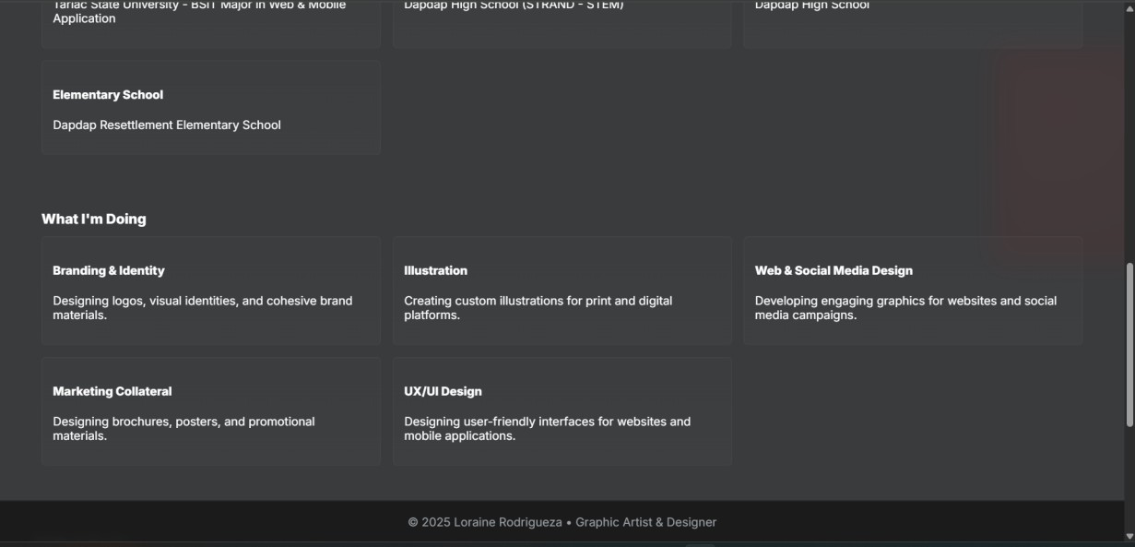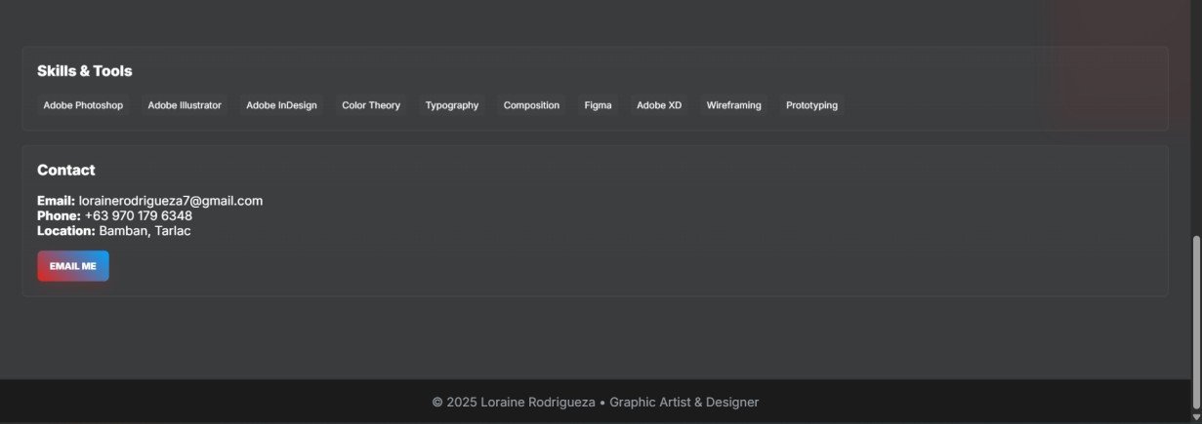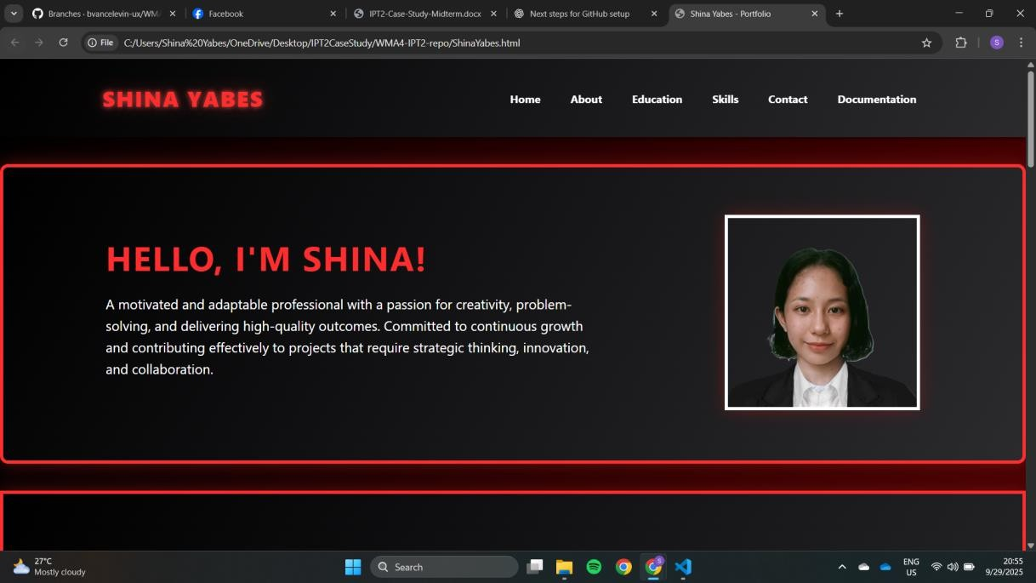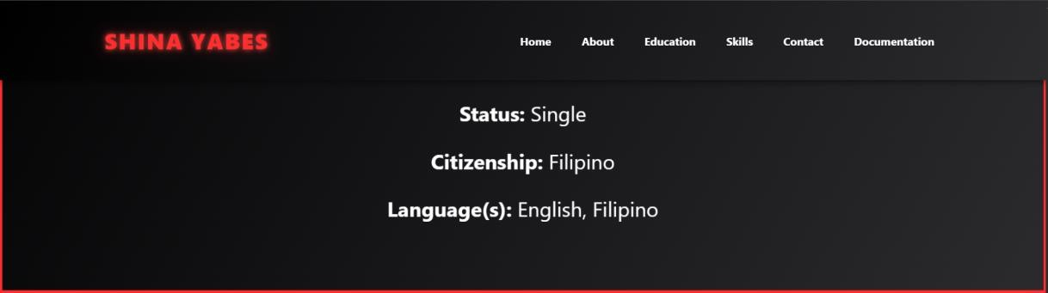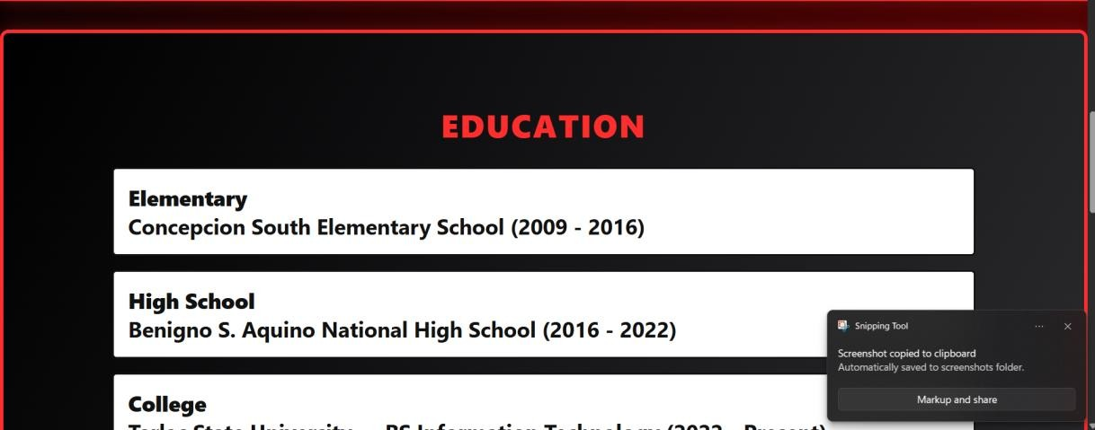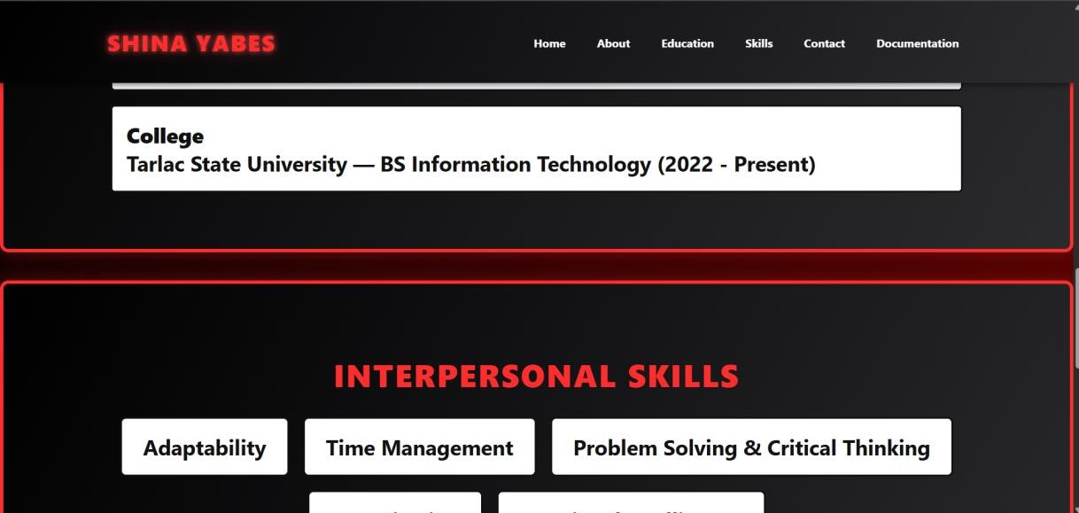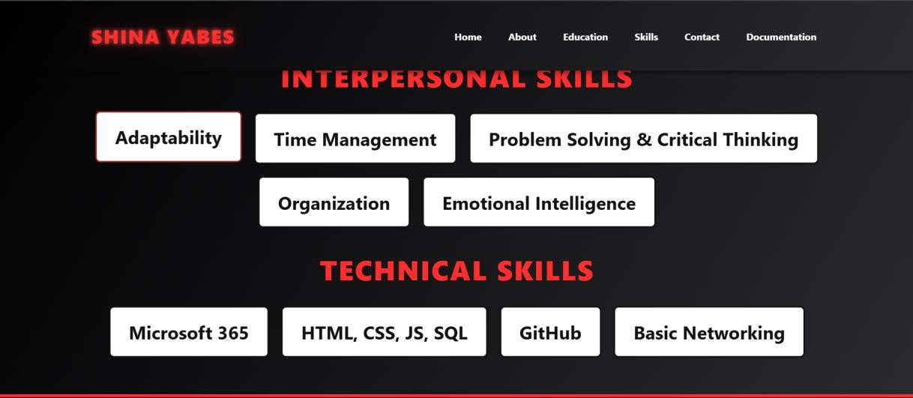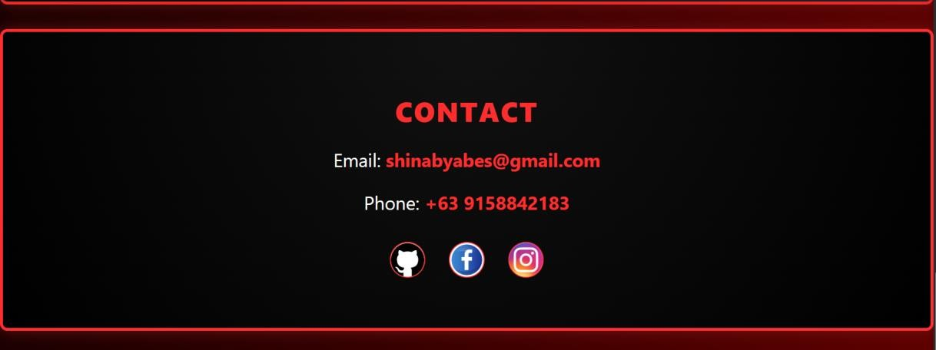

## H. References

1. Atlassian, “Git Glossary,” Atlassian, [Online]. Available: [https://www.atlassian.com/git/glossary#commands.](https://www.atlassian.com/git/glossary#commands) [Accessed: 29-Sep-2025].
2. “Best practices for using GitHub Issues,” Rewind, [Online]. Available: [https://rewind.com/blog/best-practices-forusing-github-issues/.](https://rewind.com/blog/best-practices-for-using-github-issues/) [Accessed: 29-Sep-2025].
3. Atlassian, “Git Glossary – Commands,” Atlassian, [Online]. Available: [https://www.atlassian.com/git/glossary#commands.](https://www.atlassian.com/git/glossary#commands) [Accessed: 29-Sep-2025].
4. “What is the difference/relationship between GitHub projects and milestones?” Stack Overflow, [Online]. Available: [https://stackoverflow.com/questions/39591795/what-is-the-difference-relationship-between-githubprojects-and-milestones.](https://stackoverflow.com/questions/39591795/what-is-the-difference-relationship-between-github-projects-and-milestones) [Accessed: 29-Sep-2025].